
600 Suffolk Street Tel (978) 934-4903
Lowell, MA 01854 Fax (978) 459-7915
http://ulcar.uml.edu
Center for Atmospheric Research
College of Arts and Sciences

RPI Level 0 Data formats
A detailed description of the Level 0 data sets and formats produced by the RPI instrument on the IMAGE satellite

Revision 2.7

April 5, 2000

Table of Contents
Table of Contents 2
Table of Acronyms 4
List of Tables 5
List of Figures 6
RPI Level 0 Science Data Formats 7
1 RPI Operating Modes, Waveforms, Databin Formats, and ApIDs 7
1.1 Rationale for Data Format Design 7
1.1.1 Databin Types 8
1.2 ApID Assignment 12
1.3 Operating Modes, Waveforms and Databin Formats 12
1.4 Package Structure Design 12
1.4.1 Enumerating databins per frequency 13
1.4.2 Ordering databins per frequency 13
1.4.3 Headers with auxiliary information 15
1.4.4 Filling data section of package 15
2 General Structure of RPI Data Package 15
2.1 CCSDS Preamble 16
2.2 RPI General Header 16
2.3 Preface 16
2.4 Data Header 19
2.4.1 Calculation of nominal frequencies 19
2.4.2 Calculation of total number of frequencies 22
2.5 Frequency Header 23
2.6 Data Section 23
2.7 Checksum 24
3 Calibration and conversion of measured data to physical units 25
3.1 Onboard data processing 25
Analog signal processing 25
3.1.2 Correcting gain and phase differences of X, Y, and Z receiver channels 28
3.1.3 Default and Dynamic calibration 29
3.1.4 Phase and Amplitude calibration 29
3.1.5 Scaling of X and Y channels 29
3.1.6 Despinning of X and Y channels 30
3.1.7 Digital signal processing 30
3.1.8 Linear-to-log signal compression 30
3.2 Converting RPI readings to physical units 31
3.2.1 Converting range bin number to km 32
3.2.2 Converting amplitude to field strength in [ ^{nVp}/_{m} ] 32
3.2.3 Converting thermal noise amplitudes to [ ^{dBVrms}/_{root-Hz} ] 35
3.2.4 Converting phase data to physical units 36
3.2.5 Converting Doppler bin number to Hz 36
3.2.6 Converting antenna impedance data to physical units 36
RPI Level 0 House Keeping Data Formats 38
4 (R_HK) House Keeping data sets. ApID = 0x02 38
4.1 Housekeeping Header 38
4.2 Miscellaneous status information 39
4.3 Digital Sensor Readings 39
4.4 Analog Sensor Readings 40
4.5 NoGo Table 40
4.6 RPI Power Limits 41
5 (R_SRD) Segment Report data set. ApID=0x04 42
5.1 Segment Data 42
6 (R_MSG) Software Message. ApID=0x06 42
6.1 Software Message 42
7 (R_ECH) Command Echo. ApID=0x08 44
7.1 Command Replica 44
RPI Development Package Formats 45
8 Development Package Formats 45
8.1 ApID=0x1F Frequency Set Response Package 45
8.2 ApID=0x2F Memory Read/Write Response Package 46
8.3 ApID=0x3F VME Read/Write Response Package 46
8.4 ApID=0x4F Digitizer Samples Package 47
Appendix A. Thermal Noise Data Processing 48
A1. Calculating Log Amplitudes 48
A2. Calculating Cross Power Terms (XY, XZ and YZ) 49
A3. Calculating Cross Phases (XY, XZ and YZ) 49
Appendix B. Coupler Band Center Frequency Table 50
Appendix C. Calibration Procedures 51
C1. Phase calibration procedure 51
C2. Onboard calibration procedure 52
C3. Amplitude calibration procedure 53
C3.1. Input voltage calculation 53
C3.2. Amplitude calibration coefficients 54
C3.3. Physical Units table 54

Table of Acronyms

ApID : Application ID (Telemetry Record Type)
BIT : Built In Test.
CDF : Common Data Format.
CIDP : Central Instrument Data Processor
CIT : Coherent Integration Time
DBD : Double Byte Data
HKD : House Keeping Data.
ICD : Interface Control Document.
IDFS : Instrument Data File Set
LTD : Linear Time-domain Data.
LSD : Linear Science Data
MET : Mission Elapsed Time
PPS : Pulses Per Second
PRD : Precision Range Data.
RMS : Root Mean Square
RPI : Radio Plasma Imager
SBD : Single Byte Data.
S/C : Spacecraft
SI : Science Instrument.
SMD : Spectral Maximum Data.
SPS : Staggered Pulse Sequence.
SSD : Standard Science Data.
SST : Schedule Start Time.
TN : Thermal Noise.
TPC : Transmitter Power Card.
TTD : Thermal Time-domain Data.

List of Tables

Table 1.2-1 ApID Assignment 12
Table 1.3-1 Operating Modes, Waveforms and Databin Formats 12
Table 1.4-1 Number of databins per 1 frequency 13
Table 2.0-1 General Structure of RPI Science Data Package 15
Table 2.1-1 CCSDS Preamble, Primary Header 16
Table 2.1-2 CCSDS Preamble, Time Tag 16
Table 2.2-1 RPI General Header 16
Table 2.3-1 Preface 17
Table 2.4-1 Data Header 19
Table 2.5-1 Frequency Header 23
Table 2.7-1 Checksum 24
Table 3.1-1 Nominal receiver voltage gains (X, Y, and Z) for various settings of G, in dB relative to the minimum gain at G=1. 27
Table 3.1-2 Measured receiver voltage gains for various settings of G, in dB relative to the minimum gain at G=1. 27
Table 3.2-1 Physical units for RPI science data 32
Table 3.2-2 Doppler shift frequency 36
Table 3.2-3 Antenna impedance data in physical units 37
Table 4.0-1 RPI House Keeping data format 38
Table 4.1-1 HK Header 38
Table 4.2-1 Miscellaneous status information 39
Table 4.3-1 Digital sensor readings 39
Table 4.3-2 Digital Sensor Readings 39
Table 4.4-1 Analog sensor readings 40
Table 4.5-1 NoGo Table 41
Table 4.5-2 Digital and Analog sensor flag parameters 41
Table 4.6-1 Peak and Average Power Limits 41
Table 5.0-1 RPI Segment Report data format 42
Table 5.1-1 Segment Data 42
Table 6.0-1 RPI Segment Report data format 42
Table 6.1-1 Software message 42
Table 6.1-2 Message Codes and Parameters 43
Table 7.0-1 RPI Command Echo format 44
Table 7.1-1 Command Replica 44
Table 8.1-1 Frequency Set Response package, ApID=0x1F 45
Table 8.2-1 Memory Read/Write Response package, ApID=0x2F 46
Table 8.3-1 VME Read/Write Response package, ApID=0x3F 46
Table 8.4-1 Digitizer Sample package, ApID=0x4F 47
Table C3-1 X/Y Amplitude Corrections and Physical Units table. 55

List of Figures

Figure 1.1-1 Linear Time Domain (LTD) databin 8
Figure 1.1-2 Spectral Science Data (SSD) databin 8
Figure 1.1-3 Spectral Maximum Data (SMD) databin 9
Figure 1.1-4. Precision Group Data (PRD) databin 9
Figure 1.1-5 Calibration Data (CAL) databin 10
Figure 1.1-6 Double and Single Byte Data (DBD, SBD) databins 10
Figure 1.1-7 Thermal-noise Time-domain Data (TTD) databin 11
Figure 2.4-1 Example of nominal frequency calculations: linear steps, 4 multiplexed frequencies 20
Figure 3.1-2 Three signal processing channels in RPI. 26
Figure 3.1-3 Voltage gain of receivers with preamplifiers for gain G = 15. 27
Figure 3.1-4 Desired effect of amplitude and phase corrections to X and Y output voltages. 28
Figure 3.2-5 Conversion of amplitudes to physical units. 33
Figure 3.2-6 Physical units conversion for thermal noise data 35
Figure C1-1 Phase calibration setup with HP synthesizer 51
Figure C2-1 Application of calibration signals to X(Y) and Z receiver channels 52
Figure C3-1 Amplitude calibration setup with HP synthesizer 53
Figure C3-2 Z channel voltage per digitizer unit, [nV]. 54

RPI Level 0 Science Data Formats

RPI Operating Modes, Waveforms, Databin Formats, and ApIDs

Rationale for Data Format Design
RPI is capable of producing data volumes much too high for the telemetry channel throughput. For example, with 5% logarithmic stepping through the nominal frequency band, 128 ranges, 16 repetitions per frequency and 2 polarizations, total data volume collected during a single RPI sounding measurement is
(12 bit in-phase +12 bit quadrature samples) *
3 antennas *
16 Doppler lines *
128 ranges *
2 polarizations
* 142 frequencies = 5,234,688 bytes
With provision of up to 256 Doppler lines, 1024 ranges and smaller frequency steps these volumes may become even larger.
To overcome the problem of high data traffic, a number of measures is devised.
- Onboard Rice Lossless compression performed by CIDP.
- Data thresholding, which can substantially improve compression ratio.
- Logarithmic (lossy) compression. 33% data reduction can be achieved by storing 8 bit logarithmic scale amplitudes and 8 bit phases instead of 12 bit linear scale quadrature components.
- Storing phase differences instead of absolute phases. 16% reduction of spectral data per range bin comes from storing two phase differences relative to the third phase instead of three phases of all three antennas.
- Collapsing of complete spectrum to one Doppler line by selecting the spectrum peak. This is equivalent to considering only one echo per range.
- Collapsing three antennae to one antenna by r.m.s. averaging of amplitudes.
It is not necessary to apply all data reduction measures simultaneously. Only onboard compression of data by CIDP is performed always on all RPI data categories. Data thresholding ratio is specified as a measurement program parameter Z (see RPI Commanding document, Section 1.4.2, Table 1.4-1) which can be optimally adjusted by RPI flight software to control data volume. Logarithmic compression proved to be efficient for storage of spectral domain data (see Section 1.1.1 below), and in this case phase differences are always stored instead of absolute phases. Collapsing spectrum and antenna data are strong measures affecting amount of science information and should be used with caution.

Databin Types
There is essentially one universal data package format developed for RPI data, which uses different types of a basic measurement unit called a "databin". The databin consists of all measurement data associated with one range/Doppler bin (i.e. log amplitude and phase bytes, or alternately real and imaginary amplitudes for 1 or 3 antennas, Doppler position).
Figure 1.1-1 shows Linear Time Domain (LTD) databin contents. The antenna voltages are sampled twice with 90° phase delay to obtain two 12 bit quadratures per antenna, totaling 9 bytes per databin. The LTD format can be best used for time-domain data (SPS mode, relaxation sounding, chirp sounding).
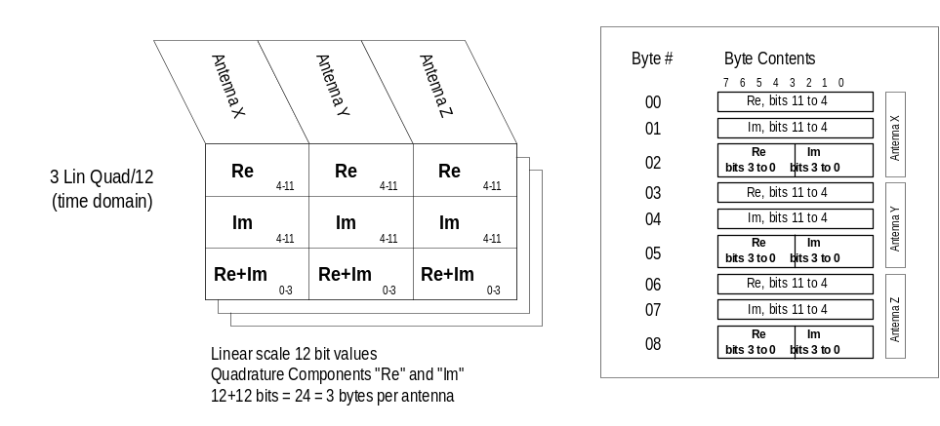
Figure 1.1-1 Linear Time Domain (LTD) databin

A more compact Spectral Science Data (SSD) databin (see Figure 1.1-2) is best suited for storing individual lines of Doppler spectrum.
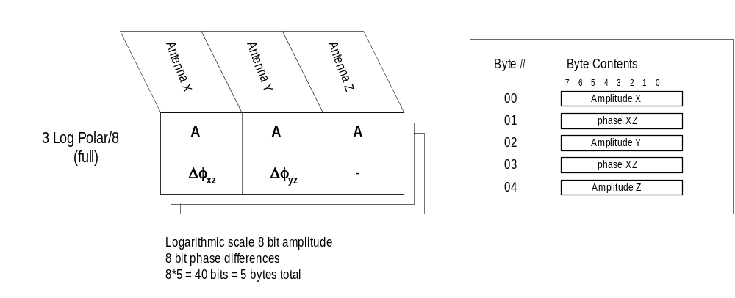
Figure 1.1-2 Spectral Science Data (SSD) databin

SSD databin can be obtained from the LTD databin by:
- converting the quadratures to a “polar” representation (i.e., amplitude and phase),
- reducing them to 8 bits (logarithmic compression for the amplitude), and
- subtracting phase of antenna Z from the all phases.
Collapsing of complete Doppler spectrum to one line requires storing its Doppler number in the output data bin. Corresponding format 3-Log Polar/8-reduced is shown in Figure 1.1-3.
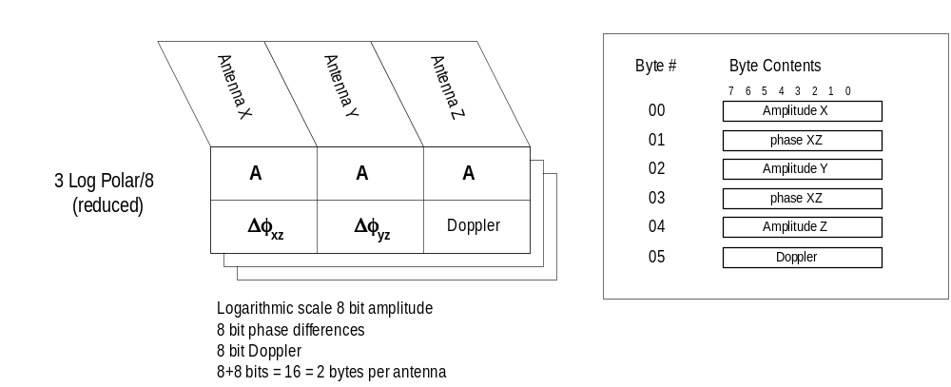
Figure 1.1-3 Spectral Maximum Data (SMD) databin

Precision Group Range technique involves sounding on two closely spaced frequencies with reduction of both frequency data to one Doppler line and calculating phase differences with respect to selected phase on the second frequency. The PRD format (Figure 1.1-4) requires storing three amplitudes, five phase differences and one Doppler line.
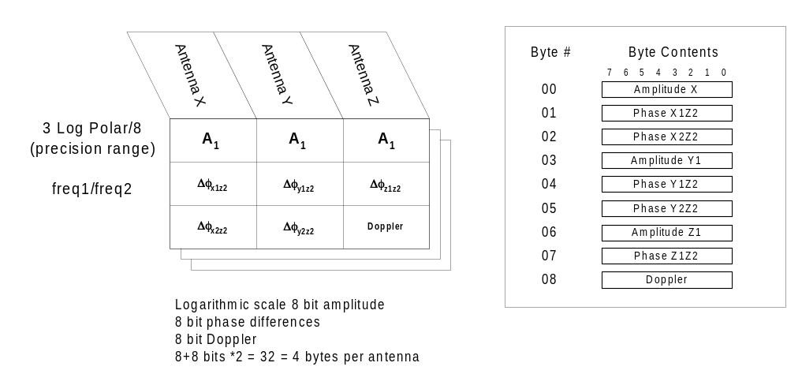
Figure 1.1-4. Precision Group Data (PRD) databin

Figure 1.1-5 shows the databin contents for calibration data, which is very similar to SMD or SSD formats, but stores three amplitudes and three (absolute) phases.
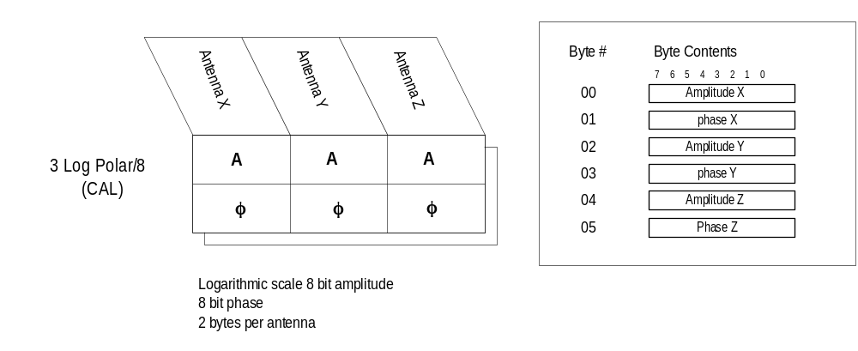
Figure 1.1-5 Calibration Data (CAL) databin

Another two formats are envisioned to store one antenna data, with r.m.s. average amplitude calculated over three antennas. Double Byte Data (DBD) databin stores 1 byte log scale r.m.s. amplitude and 1 byte Doppler number (Figure 1.1-6). SBD (Single Byte Data) databin further reduces resolution of amplitude and Doppler to fit them in 1 byte.
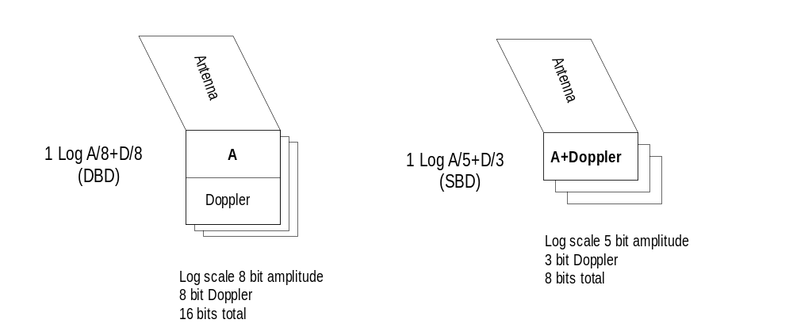
Figure 1.1-6 Double and Single Byte Data (DBD, SBD) databins
Finally, a databin format is provided for the Thermal noise Time-domain Data (TTD). In this measurement mode, the following operations are made for each frequency:
- For each antenna, 4(2^{N})+4 raw quadrature samples are collected. N is the standard RPI parameter used to specify number of transmitted pulses. No transmission is done in the thermal noise mode, and all samples are taken consecutively with 3.2 ms sampling period.
- 2^{N} averaged log amplitudes are computed using 8-point sliding window with 50% overlay.
- For each set of 8 averaged amplitudes (36 raw quadrature samples), three cross-power terms are calculated (corresponding to the antenna pairs XY, XZ, and YZ).
Figure 1.1-7 shows the TTD databin layout.
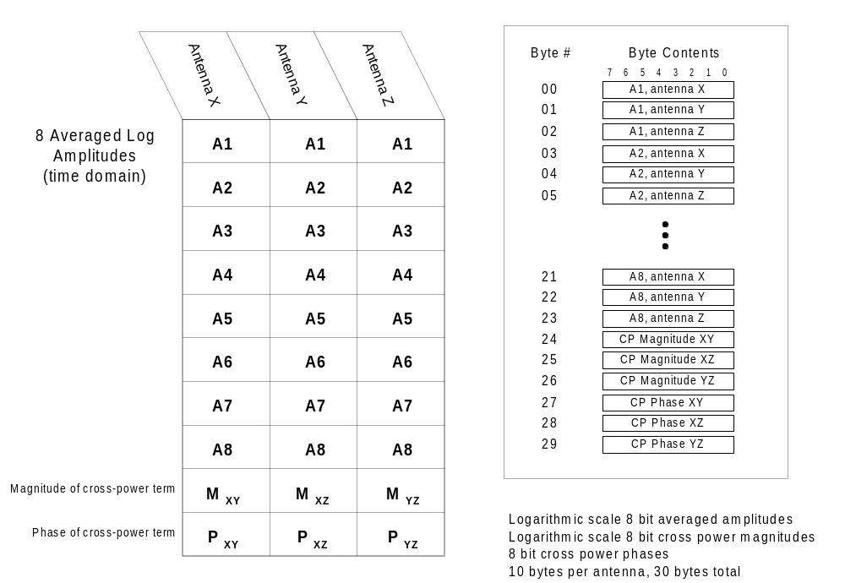
Figure 1.1-7 Thermal-noise Time-domain Data (TTD) databin
One TTD databin accommodates:
- eight averaged amplitudes per antenna, totaling 8 x 3 = 24 logarithmic scale amplitudes, and
- one set of the amplitude and phase of the cross-power terms XY, XZ, and YZ.
Total size of one TTD databin is therefore 24+6 = 30 bytes. Minimum 36 samples (N=3) per antenna have to be collected to produce a good data package with a single TTD databin per frequency. Maximum value of N is 8, with 32 TTD databins per frequency.
A detailed description of onboard thermal noise data processing is given in Appendix A.

ApID Assignment
Each RPI data package is assigned an ApID, which is selected depending on the Databin format as indicated in Table 1.2-1.
Table 1.2-1 ApID Assignment
Databin | CAL | DBD | LTD | SMD | SBD | PRD | SSD | TTD
Preface [D] | 1 | 2 | 3 | 4 | 5 | 6 | 7 | 8
ApID | 0x0C | 0x20 | 0x30 | 0x40 | 0x50 | 0x60 | 0x70 | 0x10

There are four types of the science data packages designed to be used during development only. The "development" packages are listed and described in Section 8.

Operating Modes, Waveforms and Databin Formats
Table 1.3-1 reviews the available choice of RPI scientific data formats, depending on selection of operating mode and waveform.
Table 1.3-2 Operating Modes, Waveforms and Databin Formats
Operating Mode | Waveform | Databin Format | L0.5 Data Format | L1 Data Format
Sounding  [O]=S | SPS (X=3) | LTD (D=3) | UDF | CDF  Plasmagram
Sounding  [O]=S | Chirp (X=2) | DBD (D=2)  LTD (D=3)  SMD (D=4)  SBD (D=5)  PRD (D=6)  SSD (D=7) | UDF | CDF  Plasmagram
Sounding  [O]=S | Complimentary code (X=1,8,9) |  | UDF | CDF  Plasmagram
Sounding  [O]=S | Long pulse (X=4) |  | UDF | CDF  Plasmagram
Sounding  [O]=S | Short pulse (X=5) |  | UDF | CDF  Plasmagram
Thermal Noise  [O]=T | X=0 | TTD (D=8) | UDF | CDF  Dynamic Spectrogram
Relaxation  [O]=R | Short pulse (X=5) | LTD (D=3) | UDF | CDF  Plasmagram
Whistler  [O]=W | 0.5 sec pulse (X=6) | LTD (D=3) | UDF | CDF  Plasmagram
Whistler  [O]=W | 1.95 sec pulse (X=7) | No output (D=0) | N/A | N/A
Calibration  [O]=C | Short pulse (X=5) | CAL (D=8) | UDF | N/A

Package Structure Design
Arrangement of data into packages imposes two constrains on the data format design:
- Packages of the same ApID must have a fixed size.
- Design should be robust to the loss of some packages during transfer.
A provision must be made to store, for each frequency, the following auxiliary information:
- MET offset from nadir to calculate spin phase
- Frequency offset obtained during search of the quietest frequency
- Autogain selection
- Antenna Impedance data
The size of data collected at a single frequency may vary substantially. In relaxation sounding mode with 8 ranges, 1 polarization, and single byte SBD content total amount of data per frequency is 8 bytes. In a regular sounding with N=5 (32 Doppler lines), 128 ranges, 2 polarizations and 5 byte SSD content the data per frequency amounts to 40,960 bytes. Thus, structuring of data into packages has to account for possible irregular insertion of auxiliary frequency information in the data.

Enumerating databins per frequency
The data format design suggests enumeration of all databin types (Figures 1.1-1 to 1.1-7) collected at a particular frequency. Table 1.4-1 enlists the expected number of databins in various RPI measurement modes and data formats.
Table 1.4-3 Number of databins per 1 frequency
Mode | Waveform | Databin format | Number of databins per 1 frequency
Sounding  [O]=S | SPS  [X]=3 | LTD | # of ranges * # polarizations
Sounding  [O]=S | Pulse modes  [X]=1,4,5,8,9 | LTD | # Doppler lines * # of ranges * # polarizations
Sounding  [O]=S | Pulse modes  [X]=1,4,5,8,9 | SSD | # Doppler lines * # of ranges * # polarizations
Sounding  [O]=S | Pulse modes  [X]=1,4,5,8,9 | SMD | # of ranges * # polarizations
Sounding  [O]=S | Pulse modes  [X]=1,4,5,8,9 | DBD | # of ranges * # polarizations
Sounding  [O]=S | Pulse modes  [X]=1,4,5,8,9 | SBD | # of ranges * # polarizations
Sounding  [O]=S | Pulse modes  [X]=1,4,5,8,9 | PRD | # of ranges * # polarizations
Sounding  [O]=S | Chirp  [X]=2 | SSD | # Doppler lines * # of ranges * # polarizations
Sounding  [O]=S | Chirp  [X]=2 | SMD | # of ranges * # polarizations
Sounding  [O]=S | Chirp  [X]=2 | DBD | # of ranges * # polarizations
Sounding  [O]=S | Chirp  [X]=2 | SBD | # of ranges * # polarizations
Sounding  [O]=S | Chirp  [X]=2 | LTD | # repetitions * # of ranges * # polarizations
Relaxation  [O]=R | Short pulse  [X]=5 | LTD | # of ranges * # polarizations
Whistler  [O]=W | 0.5 sec pulse  [X]=6 | LTD | # of ranges * # polarizations
Calibration  [O]=C | Short Pulse  [X]=5 | CAL | 1

Ordering databins per frequency
The order in which the databins are stored is always:
- Doppler line #1 to N (program parameter N raised to power 2) (fastest index)
- Range #
- Polarization (slowest index)
With this arrangement, for any given databin number it is possible to restore its range bin #, polarization and, if used, Doppler line # or repetition #. The following equations for databin number apply:
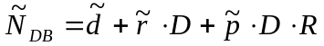 (1.4-1)
where
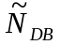 = databin number
D = total number of Doppler lines,
R = total number of ranges (always assumed 1 for TTD databin)
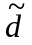 = databin Doppler line
= databin range bin number
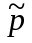 = databin polarization
~ means numbering from 0 to n-1 instead of 1 to n.

Restoring of databin parameters is done as follows:
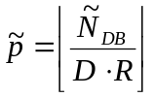 (1.4-2)
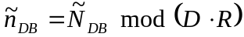 (1.4-3)
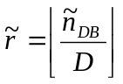 (1.4-4)
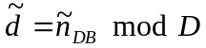 (1.4-5)

Let’s consider the following example:
RPI Sounding, Complimentary Code X=1, SSD databin, 16 Doppler lines, 64 ranges, 2 polarization. Total number of databins per frequency is 16*64*2 = 2048. The databin at Doppler line d = 4 of 16, range r = 8 of 64 and polarization p = 2 of 2 has databin serial number, according to (1.3-1),
(of 2048)
Reverse calculations using (1.3-2 – 1.3-5) give:
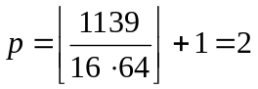 (of 2)
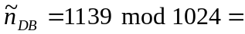115
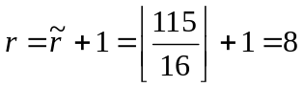(of 64)
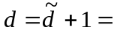115 mod 16 + 1= 4 (of 16)

Headers with auxiliary information
There are two types of headers designed to store complete per-frequency auxiliary information and ensure proper data handling in case of telemetry loss. A Data Header is stored once per package with Frequency reading, MET nadir offset time and databin serial number related to the first databin in the data portion of the package. The Data Header provides information necessary to proceed with data unpacking in case of missing previous telemetry packet. A Frequency Header precedes each numerated sequence of databins, containing autogain and frequency search settings, most probable amplitude, and antenna impedance characteristics. The Frequency Header provides necessary per-frequency information.
Detailed description of the headers can be found in Section 2.

Filling data section of package
There is no difference in arrangement of the package for different science data other than contents of the databins. The databins are stored in a package one by one in accordance to the order described in section 1.4.2 (Next Doppler line# - next range – next polarization). The length of data section in packages is fixed at 3072 bytes (to meet the requirement to have fixed package lengths for particular ApID). When the end of the defined 3072 byte data section is reached and no more databins can fit the package, the unused part is zero filled. But, if the end of one frequency is reached before the end of the data block is reached, a frequency header is inserted (again, if there is no room for the frequency header at the end of the data block the block is zero filled). Each new data block contains enough information in the header to identify the first data bin contents, even if the preceding telemetry block is lost.

General Structure of RPI Data Package
All Scientific Data Formats have identical general structure of the package as indicated in Table 2.0-1. The structure always includes CCSDS Preamble, General Header, Preface, Data Header, Frequency Header, Data Section and Checksum.
Table 2.0-4 General Structure of RPI Science Data Package
 | RPI Data Block
Sec_2.1 | Sec_2.2 | Sec_2.3 | Sec_2.4 | Sec_2.5 | Sec_2.6 | Sec_2.7
CCSDS Preamble | General Header | Preface | Data Header | Frequency Header | Data Section | Checksum
(12 bytes) | (3 bytes) | (103 bytes) | (13 bytes) | (10 bytes) | (3072 bytes) | (1 byte)

CCSDS Preamble
The standard CCSDS preamble consists of 6 byte Primary Header and 6 byte Time Tag, as shown in Table 2.1-1 and 2.1-2.
Table 2.1-5 CCSDS Preamble, Primary Header
Byte Count No. | Byte Offset No. | Byte Length | Description | Units | Type | Range
0..1 | 0..1 | 2 | 16 bit ApID data:  HHHHHiiiiAAAAAAA  H- header indicator  i – instrument ID  A – ApID | N/A | Hex | N/A
2..3 | 2..3 | 2 | Sequence Counter | N/A | Unsigned short | N/A
4..5 | 4..5 | 2 | Byte Count | N/A | Unsigned short | 0-65535

Table 2.1-6 CCSDS Preamble, Time Tag
Byte Count No. | Byte Offset No. | Byte Length | Description | Units | Type | Range
6..9 | 6..9 | 4 | MET Coarse Time | 100 ms | Unsigned long | 0 to 4294967296
10..11 | 10..11 | 2 | MET Fine Time | 195.3125 us | Short | 0, 128-65408

RPI General Header
The general header format is standard for all science data packages. The only difference is in the value content of the ApID. The header identifies the data type, the preface length and the software version number.
Table 2.2-7 RPI General Header
Byte Count No. | Byte Offset No. | Byte Length | Description | Units | Type | Range
12 | 0 | 1 | Application Identification ApID | N/A | int | exact
13 | 1 | 1 | Preface length | N/A | int | 100
14 | 2 | 1 | Software Version Number | N/A | int | 0-255

Preface
The “Preface” is standard to for all science data. The Preface (Table 2.3-1) contains the data headers that serve to tag the time/satellite characteristics for each measurement as well as list the required parameters to identify the RPI mode of operation. Unless otherwise specified all values are integers. Note: items in the “description” column that are followed by a bracketed abbreviation (e.g. [L]) correspond exactly to measurement parameters specified in the program parameters in the “Measurement Parameter Table” data (see RPI Commanding document, Section 1.4, Table 1.4-1).

Table 2.3-8 Preface
Byte Count No. | Byte Offset No. | Byte Len | Code | Description | Units | Type | Range
15..18 | 0..3 | 4 |  | Mission Elapsed Time of last nadir [MET] Stamp. | 100 millisec | Long | 0 to 4294967296
19 | 4 | 1 |  | Schedule # | N/A | Byte | 1-32
20 | 5 | 1 |  | Program # | N/A | Byte | 1-64
21..22 | 6..7 | 2 | 01 (L) | Lower Frequency Limit | 1kHz | Short | 3kHz-3MHz
23..24 | 8..9 | 2 | 02 (C) | Coarse Frequency  If > 0 log steps  If < 0 linear steps | 1%  100 Hz | Short | 1-100%  100Hz-1MHz
25..26 | 10..11 | 2 | 03 (U) | Upper Frequency Limit | 1kHz | Short | 3kHz-3MHz
27..28 | 12..13 | 2 | 04 (F) | Fine Frequency Step | 100 Hz | Short | 100Hz-1MHz
29 | 14. | 1 | 05 (S) | No. of fine steps  (no zero value)  negative value disables multiplexing | Unit | Byte | +1 to +8  -1 to -8
30..33 | 15..18 | 4 | 06 (X) | Tx Waveform *  0 = no waveform (passive msmt)  1 = Complimentary (51 msec)  2 = FM/CW “Chirp” (125 msec)  3 = Staggered Pulse (786 chips)  4 = Long Pulse (125 msec)  5 = Short Pulse (3.2 msec)  6 = 0.5 sec Pulse  7 = 1.95 sec Pulse  8 = 8 chip complimentary pulse (25 msec)  9 = 4 chip complimentary pulse (13 msec)  -1 to –9 same but no phase switching  up to four multiplexed waveforms are supported | Table | Four signed bytes | -9 to +9  (no zero value)  Each byte contains information on a waveform used in the run
34..37 | 19..22 | 4 | 07 (A) | Tx Antenna options *  1 = Radio Silent (no Tx)  2 = X antenna only  3 = Y antenna only  4 = X+Y in linear polarization  5 = Right Circular Polarization RCP  6 = Left Circular Polarization, LCP  7 = RCP & LCP alternate w.r.t. +Z  8 = X+Y switch linear Pol by 90°  -1 to –7 same but bypass antenna coupler | Table | Four signed bytes | -8 to +8  (no zero value)
38..41 | 23..26 | 4 | 08 (N) | No. of Integrated Repetitions *  Negative means power integration instead of coherent integration | 2^{N} | Four signed bytes | -8 to +8
42..45 | 27..30 | 4 | 09 (R) | Pulse Repetition Rate*  0 = 0.5 pps  1 = 1.0 pps  2 = 2.0 pps  3 = 4.0 pps  10 = 10 pps  20 = 20 pps  50 = 50 pps | Table | Four bytes | 0, 1, 2, 4, 10, 20, 50
46-49 | 31-34 | 4 | 10 (O) | Operating Mode*  0 = Standby  1 = Calibration  2 = Relaxation  3 = Sounding  4 = Thermal Noise  5 = Whistler  6 = Test Pattern | Table | Four bytes | 0 to 5
50 | 35 | 1 | 11 (W) | Power Limit constraint | Watts | Byte | 0-120
51 | 36 | 1 | 12 (E) | Start Range 960 km units | 1 Mm | Byte | 0 to 255
52 | 37 | 1 | 13 (H) | Range Resolution | 10 km | Byte | 24 or 48
53..54 | 38..39 | 2 | 14 (M) | No. of range bins  8, 16, 32, 64, 128, 256, 512, 1024 | Unit | Byte | 8 to 1024
55 | 40 | 1 | 15 (G) | Base Gain  negative = Fixed Gain  positive = Automatic Gain | Table | Byte | -18 to +18
56 | 41 | 1 | 16 (I) | Frequency Search  0 = Disabled  n = 5 freq spaced by n*244 Hz  negative = Default calibration  positive = Dynamic calibration | Table | Byte | -9 to +9
57..58 | 42..43 | 2 | 17 (P) | No. of ranges stored  1-1024 | Unit | Short | 1 to 1024
59 | 44 | 1 | 18 (B) | Bottom of range window | 1 Mm | Byte | 0 to 250Mm
60 | 45 | 1 | 19 (T) | Top of range window | 1 Mm | Byte | 0 to 250Mm
61..64 | 46..49 | 4 | 20 (D) | Databin Format*  0 = No Data  1 = Calibration – CAL  2 = Double Byte Data – DBD  3 = Linear Time Domain – LTD  4 = Spectral Maximum Data –SMD  5 = Single Byte Data – SBD  6 = Precision Range Data – PRD  7 = Spectral Science Data – SSD  8 = Thermal Time Domain – TTD | Table | Four bytes | 0 to 8
65..68 | 50..53 | 4 | 21 (Z) | Threshold cleaning, in % *  0 = no thresholding | % | Four bytes | 0 to 99
69-71 | 54-56 | 3 | 22 | Spare program parameter
72 | 57 | 1 |  | High RF Noise setting, 0 = no,  1 = yes. | Unit | Byte | 0 or 1
73..74 | 58..59 | 2 |  | CIT length | 10 ms | Byte | 0 to 650sec
75 | 60 | 1 |  | Number of multiplexed programs | unit | Byte | 1
76..77 | 61..62 | 2 |  | Data Status Flags | N/A | Short | N/A
78..81 | 63..66 | 4 |  | Spin Axis Inertial X component | 2s Co. | Int | -1 to +1
82..85 | 67..70 | 4 |  | Spin Axis Inertial Y component | 2s Co. | Int | -1 to +1
86..89 | 71..74 | 4 |  | Spin Axis Inertial Z component | 2s Co. | Int | -1 to +1
90..93 | 75..78 | 4 |  | Spin Phase Angle | Deg. | Int | -180 to 180
94..97 | 79..82 | 4 |  | Filtered Spin Rate Magnitude | R/Min | Int | +/- 21.4748..
98.. 101 | 83..86 | 4 |  | MET Coarse @ which Star Tracker is valid | 100 ms | Int | 0 to 4294967296
102.  105 | 87..90 | 4 |  | MET coarse time of periapse passage | 100 ms | Int | 0 to 4294967296
106..  107 | 91..92 | 2 |  | Semi-major axis | 1 km | Short | 0-65535
108..  109 | 93..94 | 2 |  | Eccentricity, nominally .4 | LSB=  3*10⁻⁵ | Short | 0-1
110..  111 | 95..96 | 2 |  | Cosine of angle of inclination | LSB=  3*10⁻⁵ | Short | 0-1
112..  113 | 97..98 | 2 |  | Argument of Perigee | LSB=  5.5*10⁻³ | Short | 0-360
114..  115 | 99..  100 | 2 |  | Longitude of the Ascending Node | LSB=  5.5*10⁻³ | Short | 0-360
116..  117 | 101..  102 | 2 |  | Distance to earth center | 1 km | Short | 0-65535
* indicates up to four parameters may be packed into four bytes. The packing order is reversed, i.e., as byte count increases, the program index decreases from 3 to 0.

Data Header
The “Data Header” (see Table 2.4-1) contains information necessary to retrieve the databins correctly in case of telemetry losses. See Section 1.4.3 for more details on auxiliary headers design.
Table 2.4-9 Data Header
Byte Count No. | Byte Offset No. | Byte Length | Description | Units | Type | Range
118..119 | 0..1 | 2 | Frequency step number | unit | Short | 1-65535
120..121 | 2..3 | 2 | Time offset from nadir MET | 0.1sec | Short | 0 to 6553 sec
122-125 | 4..7 | 4 | Serial number of the first databin in the package, | unit | Long | 0-262143
126-129 | 8..11 | 4 | Total number of databins per frequency | unit | Long | 8-262144
130 | 12 | 1 | Multiplexed program number | unit | Byte | 0-3

Calculation of nominal frequencies
RPI selects the actual frequency for transmission by searching for the quietest frequency around the nominal frequency. To obtain the actual sounding frequency,
- the nominal frequency shall be calculated using the Frequency Step Number stored in the Data Header,
- the frequency search adjustment shall be applied using Frequency Search parameter from the Frequency Header.
The Frequency Step Number is converted to the corresponding nominal frequency in kHz using information stored in the Preface. For linear frequency stepping, the nominal frequency is:
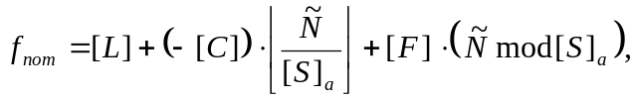 (2.4-1)
where
[L] is Lower Frequency Limit from the Preface,
[C] is Coarse Frequency Step (reported negative in this case),
[S]_{a} is the absolute value of Number of Fine Steps,
[F] is Fine Frequency Step, and
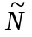 is frequency step number from the Data Header.
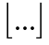 is the floor function (the largest integer smaller than the argument)
mod is modulo function (the remainder of integer division).
Example (see Figure 2.4-1):
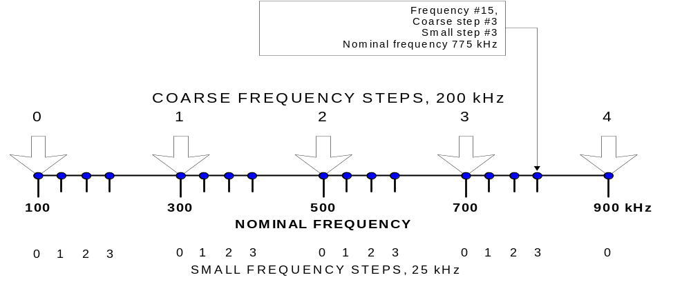 [L] = 100, [C] = -2000 (i.e., 200 kHz), [S] = -4, [F] = 250 (i.e., 25 kHz), =15
Figure 2.4-8 Example of nominal frequency calculations: linear steps, 4 multiplexed frequencies

For logarithmic frequency stepping, the nominal frequency is:
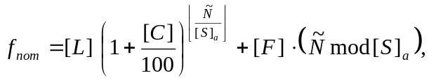 (2.4-2)
where
[L] is Lower Frequency Limit,
[C] is Coarse Frequency Step (in %),
[S]_{a} is the absolute value of Number of Fine Steps,
[F] is Fine Frequency Step, and
is frequency step number from the Data Header.
The [S] Fine Steps are linearly spaced.
Example 1:
[L]=100, [C]=10, [S]=8, [F]=3, =23
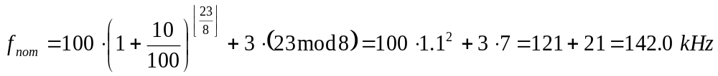
Example 2:
[L]=3, [C]=5, [S]=1, [F]=don't care, =100
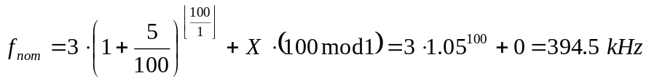
Note that is [C] is a multiple of 3 (3, 6, 9, 12…), the frequency stepping is not "logarithmic", but "coupler band centers" (see explanations below).
For coupler band centers frequency stepping, i.e., when [C] is a positive multiple of 3 (3, 6, 9, 12…) the nominal frequency is taken from a pre-defined table of frequencies. Each of the table frequencies is the center of a coupler band where the maximum efficiency of the tuned transmission is reached. Table of the coupler central frequencies is given in Appendix B.
To convert the frequency index to nominal frequency for the coupler band centers stepping mode, the following procedure shall be used:
- Find the table frequency closest to the Lower Frequency Limit, [L]. (The closest table frequency may appear to be lower or higher than [L].) The found frequency, f_{t0}, will be the first sounding frequency in the measurement, and its index, ,is therefore 0. The index of f_{t0} in the frequency table will be i_{t0}.
- Frequency stepping is then done by incrementing the table index, i_{t}, from i_{t0} until the Upper Frequency Limit, [U], is exceeded. The increment to i_{t} can be greater than 1 if faster frequency scanning is required. For [C] equal to 3, 6, 9… the increment to the table index is 1, 2, 3…, correspondingly.
Example 1:
[L]=100, [C]=6, [S]=1, [F]=don’t care, =2
Closest table frequency to 100 kHz is 100.500 kHz, index #65. As [C] equal to 6, the table will be scanned with index increment of 2, i.e., #65 (100.5 kHz), #67 (105.0 kHz), #69 (111.5 kHz), etc. The frequency with =2 is therefore 111.5 kHz.
For fixed frequency measurements (i.e., when [L] is equal to [U]), the nominal frequency is:
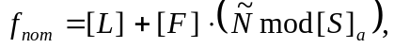 (2.4-3)
where
[L] is Lower Frequency Limit,
[S]_{a} is the absolute value of Number of Fine Steps,
[F] is Fine Frequency Step, and
is frequency step number from the Data Header.
i.e., if no frequency multiplexing is requested (i.e., [S] is 1), all frequencies are equal to [L].

Calculation of total number of frequencies
The total number of frequencies sampled in a single RPI measurement run can be obtained using the following calculations.
For linear frequency stepping, the total number of frequencies is:
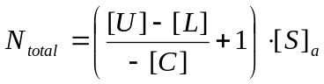 (2.4-4)
where
[L] is Lower Frequency Limit,
[U] is Upper Frequency Limit,
[C] is Coarse Frequency Step, and
[S]_{a} is the absolute value of Number of Fine Steps.

For logarithmic frequency stepping, the total number of frequencies is:
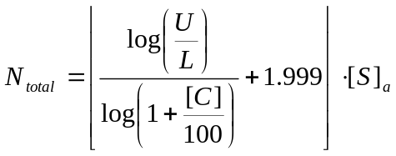 (2.4-5)
For coupler band centers frequency stepping, the total number of frequencies is
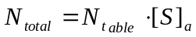 (2.4-6)
where N_{table} is number of the coarse frequency steps, which in this case have to be calculated using Table B-1 (Appendix B) containing coupler band center frequencies:
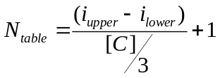 (2.4-7)
where
[C] is Coarse Frequency Step,
i_{upper} and i_{lower} are indeces of the Upper Frequency Limit, [U] and Lower Frequency Limit, [L], correspondingly, in the coupler frequency table, found by searching the table frequency closest to the nominal frequency.
For fixed frequency measurements, the total number of different frequencies is [S]_{a}, and transmission is repeated [C] times, hence
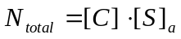 (2.4-8)

Frequency Header
The format of Frequency Header is shown in Table 2.5.1. See Section 1.4.3 for more details on auxiliary headers' design.
Table 2.5-10 Frequency Header
Byte Count No. | Byte Offset No. | Byte Length | Description | Units | Type | Range
131 | 0 | 1 | Gain offset from base gain (4 MSB)  Frequency Search (4 LSB) | double steps  n*244Hz | Nibble  Nibble | 0-3 (0,2,4,6 gain steps)  0 to 4
132 | 1 | 1 | Most probable amplitude | TBD | Byte | TBD
133 | 2 | 1 | Current on X antenna [Ix] | 10mamp | Byte | 0-2.55 amp
134 | 3 | 1 | Voltage on +X dipole antenna [V_{x1}] | 10 volt | Byte | 0-2550 Volt
135 | 4 | 1 | Voltage on -X dipole antenna [V_{x2}] | 10 volt | Byte | 0-2550 Volt
136 | 5 | 1 | Current on Y antenna [Iy] | 10mamp | Byte | 0-2.55 amp
137 | 6 | 1 | Voltage on +Y dipole antenna [V_{y1}] | 10 volt | Byte | 0-2550 Volt
138 | 7 | 1 | Voltage on -Y dipole antenna [V_{y2}] | 10 volt | Byte | 0-2550 Volt
139-140 | 8-9 | 2 | First Range Bin | Units | Short | 0-511

Storing Frequency Header in each data package is excessive if more that one package is required to hold one frequency data, but this measure provides necessary robustness of data format to telemetry data losses.

Data Section
Data Section contains an array of databins arranged in the sequential order as described in Section 1.4.1 and 1.4.2, possibly with frequency headers. The length of the Data Section is fixed at 3072 bytes.
The Data section can hold more than one frequency data and therefore store Frequency Headers (see Section 2.5 for format description) which separate individual frequency data. One Frequency Header is placed in front of every databin sequence, unless the Data Section begins with the first databin of the frequency and therefore the Frequency Header preceding the Data Section (see Section 2.5) can be used.
The actual frequency setting is not stored in the Frequency Header. To calculate actual frequency of nth frequency data in the package, the frequency step number has to be obtained first by adding the frequency step number from the Data Header (see Section 2.4) to n. Then, formulas (2.4-1) or (2.4-2) shall be used to obtain the nominal frequency. Finally, the actual frequency is obtained by applying frequency search correction to the nominal frequency:
(2.6-1)
where FS is frequency search adjustment value from the Frequency Header, and [I] is Frequency Search parameter from the Preface.

Checksum
This section contains 1 byte checksum calculated from byte 7 to end of package by successively applying Exclusive-Or operation on the bytes of the package.
Table 2.7-11 Checksum
Byte Count No. | Byte Offset No. | Byte Length | Description | Units | Type | Range
N-1 | 0 | 1 | Checksum | N/A | Byte | 0-255

Calibration and conversion of measured data to physical units

Onboard data processing
Figure 3.1-1 shows a complete diagram of RPI onboard data processing, further detailed in subsequent sections of Chapter 3. For illustration purpose, the diagram indicates an assumed signal of 100 nVp/m in the x, y, and z directions undergoing SSD processing with a gain [G] = 15 and operation at a frequency of 65 kHz. To simplify the example, the phase differences of the receivers are not reflected in the processing. The signal phase is assumed 0° so that the in-phase component I is equal to the signal amplitude, and the quadrature component Q is zero.

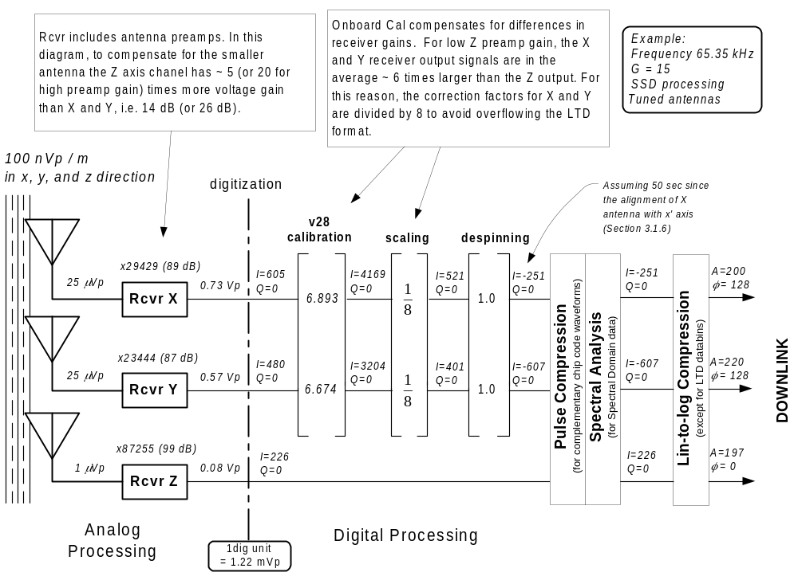 Analog signal processing
Figure 3.1-9 RPI onboard data processing.
Figure 3.1-2 shows the diagram of analog signal processing circuitry of RPI.
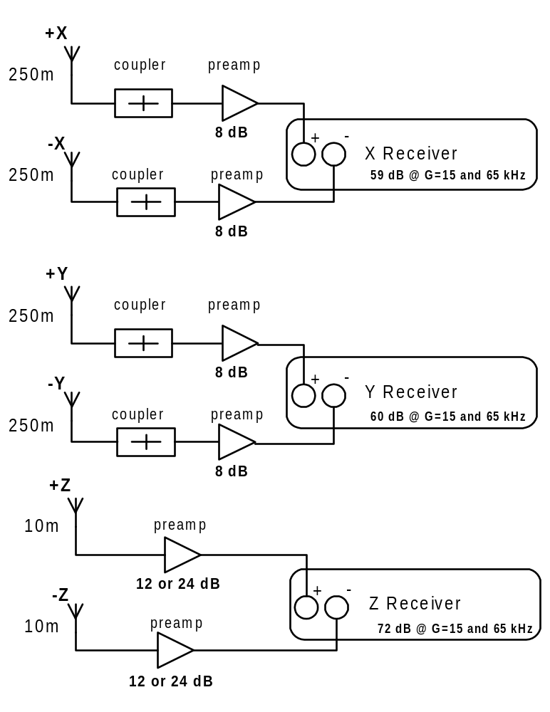Figure 3.1-10 Three signal processing channels in RPI.
As Figure 3.1-2 indicates, there are two equal channels, X and Y, each connected to a 500 m dipole antenna. Channel Z is provided with a shorter, 20 m antenna, and therefore has to compensate for the smaller input signal by yielding a higher voltage gain. The broadband preamplifiers in the Z channel have 4 dB more gain than the X/Y preamplifiers, and the Z receiver has ~10 dB more gain. This results in a ~14 dB higher gain in Z channel, unless the high gain setting is selected in the Z preamp. In the latter case, the Z channel has ~26 dB more gain.
All receivers have selectable gain that can be set fixed or chosen optimally in the autogain mode. X and Y gain setting are always set identical, the Z gain is typically greater because of the shorter Z antenna. There are 18 different combinations of two gains (Z and X/Y) that are encoded in a single value of the nominal gain, [G], as shown in Table 3.1-1. The actual gain readings (in dB above the minimum receiver gain) are provided in Table 3.1-2 for the X, Y, and Z channels. The minimum receiver gain is frequency dependent for all receiver channels, and can be derived from the calibration results as discussed below.
Table 3.1-12 Nominal receiver voltage gains (X, Y, and Z) for various settings of G, in dB relative to the minimum gain at G=1.
G | 1 | 2 | 3 | 4 | 5 | 6 | 7 | 8 | 9 | 10 | 11 | 12 | 13 | 14 | 15 | 16 | 17 | 18
dB steps | 0 | +6 | +12 | +18 | +24 | +30 | +24 | +30 | +36 | +42 | +48 | +54 | +24 | +30 | +36 | +42 | +48 | +54
Z preamp | low | low | low | low | low | low | hi | hi | hi | hi | hi | hi | low | low | low | low | low | low

Table 3.1-13 Measured receiver voltage gains for various settings of G, in dB relative to the minimum gain at G=1.
G | 1 | 2 | 3 | 4 | 5 | 6 | 7 | 8 | 9 | 10 | 11 | 12 | 13 | 14 | 15 | 16 | 17 | 18
X | 0 | 4.6 | 10.9 | 18 | 24.3 | 30.7 | 24.3 | 30.7 | 37.1 | 42.7 | 49.1 | 55.5 | 24.3 | 30.7 | 37.1 | 42.7 | 49.1 | 55.5
Y | 0 | 3.8 | 10.9 | 20.6 | 24.4 | 32.1 | 24.4 | 32.1 | 37.1 | 47.3 | 55. | 60. | 24.4 | 32.1 | 37.1 | 47.3 | 55. | 60.
Z | 0 | 5.2 | 9.3 | 20.3 | 23.5 | 29.2 | 35.5 | 40.6 | 46.7 | 56.8 | 61.9 | 68. | 23.5 | 28.6 | 34.7 | 44.8 | 49.9 | 56.
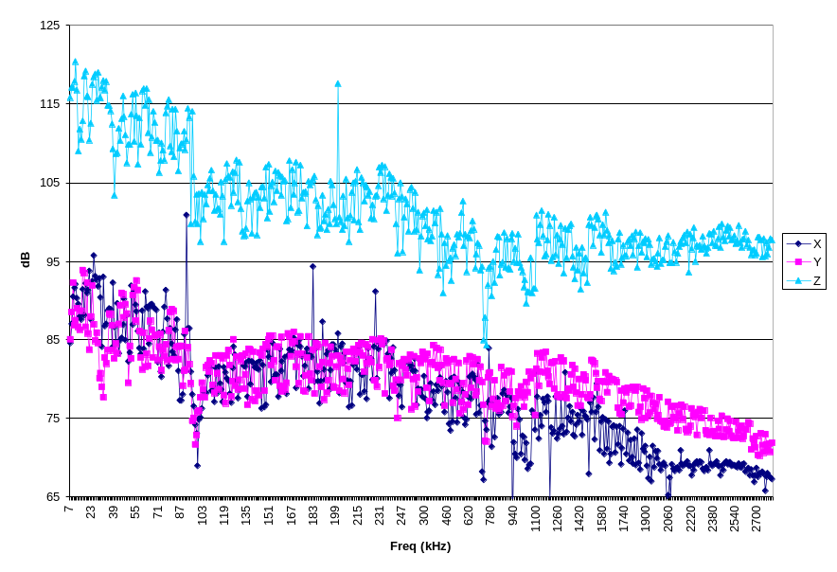Figure 3.1-11 Voltage gain of receivers with preamplifiers for gain G = 15.
Figure 3.1-3 shows the actual voltage gains in dB of the X, Y, and Z receivers for the gain setting of 15
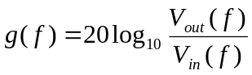 (3.1-1)
where V_{out}(f) is receiver output voltage before the digitizer, and V_{in}(f) is input voltage at the antenna terminals. Using the actual gains for G=15 and the table of measured gains relative to the minimum gain (Table 3.1-2), it is possible to calculate the gains for all frequencies and base gain settings.

Correcting gain and phase differences of X, Y, and Z receiver channels
RPI measures the 3 orthogonal components of electric field vectors and derives angle-of-arrival of the echoes reflected from magnetospheric plasma. The signals from each antenna go through individual receiver channels that introduce frequency-dependent amplification and phase shifts. Differences between the channel characteristics would introduce errors to angle-of-arrival calculations, unless corrected. Therefore, calibration of the phase and gain characteristics of the receiver channels assumes vital importance to the angle-of-arrival data validity.
To ensure proper compensation of differences between the receiving channels, RPI introduces phase and amplitude corrections, for each sounding frequency, to the quadrature components measured by the X and Y receivers. Channel Z acts as the amplitude and phase reference and therefore is passed through unchanged. The purpose of introducing the corrections is to obtain identical response of all channels to the input signal. Figure 3.1-4 illustrates the correction process, assuming identical field strengths along the x, y, and z directions.

Figure 3.1-12 Desired effect of amplitude and phase corrections to X and Y output voltages.

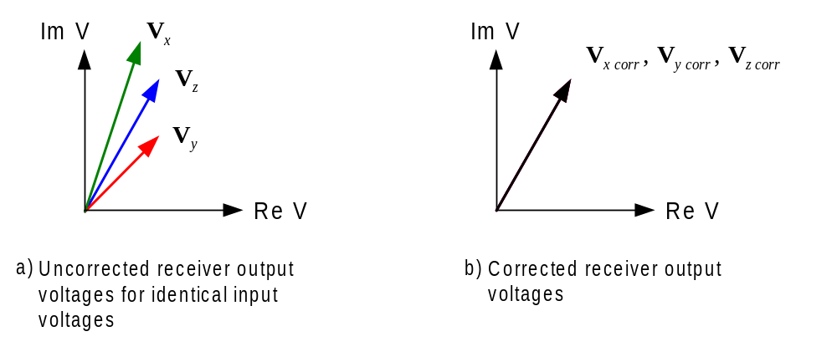
The correction applied to the X and Y channels makes the outputs identical. The actual correction factors are calculated based on measurements of the voltage gain and phase shifts of the receiver channels.

Default and Dynamic calibration
Two calibration modes are implemented
- "DEFAULT". A CAL Table is stored in the flight software with results of the X, Y, Z channel calibrations obtained in the laboratory (see description of the phase calibration procedure in Appendix C). The key disadvantage of the "default" correction algorithm is its inability to reflect the actual variability of the RPI hardware characteristics with temperature, time, mechanical impacts, etc. during the mission. Also, the CAL Table contains data collected for a particular, predefined set of frequencies, and therefore when the actual sounding frequency does not match any of the frequencies in the default CAL Table, the algorithm has to select the closest available frequency instead.
- "DYNAMIC": RPI has calibration circuitry that allows the attenuated transmitter signal to go through the receiver channels. The measured receiver response can be directly used to compensate for the inequalities. The dynamic calibration senses the actual receiver characteristics for each sounding frequency immediately before the transmission starts. However, the calibration signals for the X/Y channels are affected by the impedance characteristics of the antennas and therefore the calibration voltages applied at the receiver inputs vary with frequency. A loopback laboratory calibration was conducted to measure the amplitude and phase of the calibration source signal. Further description of the loopback calibration is given in Appendix C.
Either "default" or "dynamic" calibration can be selected in the RPI measurement programs. When dynamic calibration is chosen, it must be combined with the frequency search procedure as both of them are performed during the period of time allocated for the frequency search. Calibration data, regardless of their origin, are reported into the telemetry channel in a data package with ApID = 0x0C. The unified data format (see Section 2) is used to hold calibration data; however, there are no frequency headers in the Data Section of the CAL packets (see section 2.6).

Phase and Amplitude calibration
Gain and phase characteristics of the analog circuitry were studied in laboratory conditions, as described in detail in Appendix C.

Scaling of X and Y channels
For low Z preamp gain, the Z axis channel has ~14 dB more gain than X and Y, but the output signals from the X and Y channels will typically be larger due to the different antenna lengths. An appropriate scaling is required to optimally package all data for telemetry and avoid data storage related saturation of the X and Y readings. The scaling factor of 1/8 is introduced for the X and Y channel data, which has to be removed during ground data processing to return to the case of matched X, Y, Z channels.

Despinning of X and Y channels
After the differences in X and Y channels are removed by calibration, it becomes possible to compensate for the spinning of the X and Y antennas (nominally at 1/2 rpm). The despinning procedure calculates the projection of the E-field vector in the x', y', z' system, where
- the x' axis points to the center of the Earth,
- the z' axis, equal to the z axis, points in the direction of the orbital angular momentum, and
- the y' axis is perpendicular to the x' axis in the orbital plane.
The IMAGE spin vector points opposite to the z axis, and therefore the voltages in the primed coordinate system are
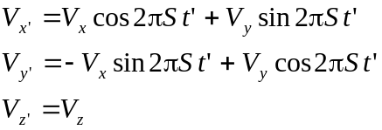 (3.1-2)
Here V_{x}, V_{y}, V_{z} are the corrected voltages in the antenna coordinate system, S is the spin rate ( S = 1/120 sec), and t' is the time measured from the last alignment of the x axis with the x' axis.

Digital signal processing
Certain RPI waveforms require specialized onboard signal processing. The processing includes pulse compression for the complementary phase code sequences, and spectral analysis for equidistant pulse sequences. For the purpose of calibration and conversion of amplitudes to physical units, it is important that the "digital" gain of the signal processing is known.

Linear-to-log signal compression

In order to reduce the telemetry data volume, some of the output data are converted to amplitude/phase representation and logarithmically compressed. The amplitude A_{lin} and phase φ can be obtained from the in-phase and quadrature samples I and Q using equation (3.1-3):
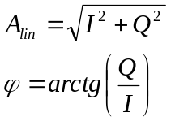 (3.1-3)
The phase ϕ is then stored in an 8-bit integer, in linear 360º/255 steps. The amplitude A_{lin} is converted to the logarithmic scale and stored in another 8-bit integer:
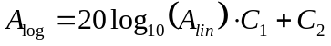 (3.1-4)
The constants C₁ and C₂ are selected to accommodate the dynamic range of A_{lin} in the 256 levels of A_{log}. The choice of C₁ and C₂ is influenced by the need to minimize real-time computations. By rewriting (3.1-4) as
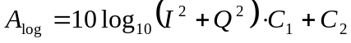 (3.1-5)
the root function does not have to be calculated. Also, log₂() function can be used instead of a slower implementation of log₁₀():
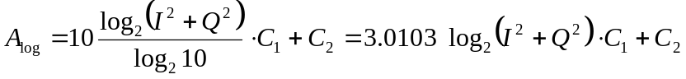 (3.1-6)
C₁ shall be then selected to allow enough dynamic range. The 12-bit digitizer produces 12 bit numerical voltage values (11 bits and sign) for I and Q. Assuming that both I and Q are saturated, the maximum A_{lin} is (2¹¹-1) · √2. For 4, 8, and 16 chip phase code waveforms, the pulse compression processing (Section 3.1.7) increases the maximum amplitude 4, 8, and 16 times, correspondingly, resulting in (2¹³-1) · √2, (2¹⁴-1) · √2, and (2¹⁵-1) · √2 values of the maximum A_{lin}. Therefore, the maximum amplitude to be ever converted to log scale is 32767 · √2 = 46340 = 93.32 dB. Making
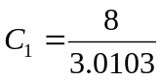 (3.1-7)
allows for 255 · 3.0103/8 ≈ 96 dB dynamic range of A_{log} and a convenient formula for A_{log} calculation:
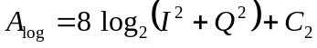 (3.1-8)
To simplify the ground processing, C₂ is selected to always reference the maximum possible value of A_{lin}, for each waveform, to the maximum level of A_{log} (i.e., 255):
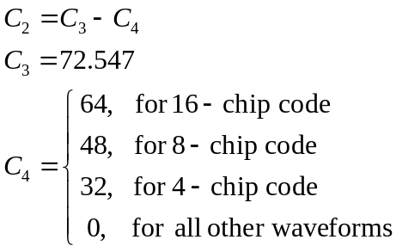 (3.1-9)
Shifting of the reference level by introducing the waveform-dependent C₄ constant normalizes the DSP gain from the pulse compression (Section 3.1.7) and thus simplifies the log-to-linear decompression algorithm discussed below in the Section 3.2.2.1.

Converting RPI readings to physical units
Table 3.2-1 shows the choice of physical units for the RPI science data.

Table 3.2-14 Physical units for RPI science data
Measured parameter | Standard units | Stored in the data as | Calibration/Conversion
Nominal Frequency | KHz | Frequency Step Number | Section 2.4.1
Range | Km | Range Bin Number | Section 3.2.1
Field Strength | nVp/m∗ | 12 bit quadrature component | Section 3.2.2
Field Strength | nVp/m* | 8 bit log amplitude, except TTD databin | Section 3.2.2
Voltage | dBV/root-Hz | 8 bit log amplitude (TTD databin) | Section 3.2.3
Antenna voltage | Vrms | 8 bit values in Frequency Header | Section 3.2.6
Antenna current | MA | 8 bit values in Frequency Header | Section 3.2.6
Phase | Degrees | 8 bit linear phase | Section 3.2.4
Doppler Frequency | Hz | Doppler Bin Number | Section 3.2.5

Converting range bin number to km
The range bin number, 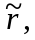 for a particular databin is obtained using Equation 1.4-4, Section 1.4.2. Then the range in km is
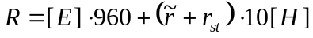 (3.2-1)
where
[E] is Start Range in 960 km units (from Preface)
is range bin number
r_{st} is First Range Bin (from Frequency Header, Table 2.5-1)
[H] is Range Resolution in 10 km (from Preface), i.e., 24 or 48

Converting amplitude to field strength in [ ^{nVp}/_{m} ]
Figure 3.2-1 details the ground processing steps to convert measured amplitudes from the raw telemetry representation to the field strengths in [ ^{nVp}/_{m} ]. Given example values continue from Figure 3.1-1.
Onboard calibration tables used by the flight software v31 and below have to be replaced by an updated calibration data now available. Before the calibration corrections to the quadrature samples can be removed, un-despinning of the data has to be done. After the new corrections are introduced, despinning has to be reapplied.

Log-to-linear decompression
RPI science data with databin formats SSD, SMD, PRD, SBD and DBD (see Section 1.1.1) report 8 bit logarithmically compressed amplitudes. The amplitudes have to be converted back to linear scale before they enter the rest of the conversion process:
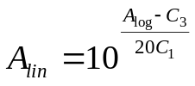 (3.2-2)
where A_{log} is the stored amplitude, and C₁ and C₃ are the compression algorithm constants:
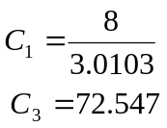 (3.2-3)
Figure 3.2-13 Conversion of amplitudes to physical units.
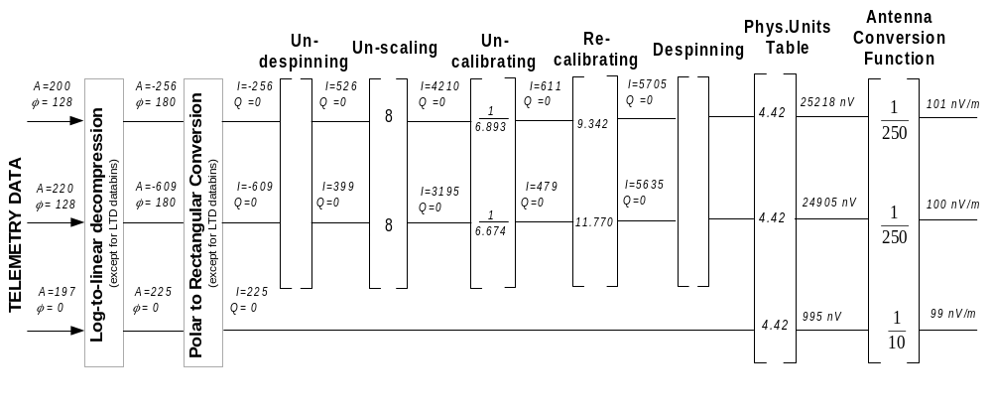

Polar to Rectangular Conversion
For spectral domain data, the in-phase and quadrature components are restored from the amplitude and phase:
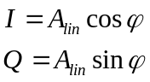 (3.2-4)
where ϕ is the phase in radians obtained from the 8-bit stored value as discussed below in Section 3.2.4.

Un-despinning
The de-spinning procedure (Section 3.1.6) has to be undone before the v28 corrections can be removed. The rotation is done in the opposite direction to de-spinning (3.1-2):
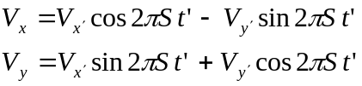 (3.2-5)
V_{x} and V_{y} are the voltages in the antenna coordinate system, S is the spin rate (1/120 sec), and t' is the time measured from the last alignment of the x axis with the x' axis. For all time domain data, t' is the time offset from the nadir, ΔT_{nadir}(f), stored in Data Header of each telemetry packet. If more than one frequency data fits one packet, ΔT_{nadir}(f) for the second, third,… frequency of the packet has to be interpolated (or extrapolated, for the last packet). For the spectral domain data, 0.5 CIT has to be added to t' (see Section 3.2.5 for CIT calculation). Spin rate magnitude S is stored in the Preface.

Un-scaling
All X and Y channel data had been scaled down by a factor of 8 for the purpose of optimal binary data storage (see Section 3.1.5). This factor has to be removed here by multiplying the amplitudes by 8.

Removing correction factors
Only amplitude corrections for the flight software v31 and below have to be removed, so the un-calibration procedure is simply:
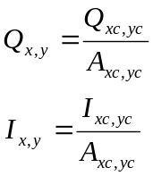 (3.2-6)
where A_{xc} and A_{yc} are the amplitude corrections introduced by the flight software. The onboard correction factors are reported in the calibration packet as 8-bit log-scale amplitudes and 8-bit phases for the channels X, Y, and Z. A_{xc} and A_{yc} can be restored from CAL packet data using the following formula:
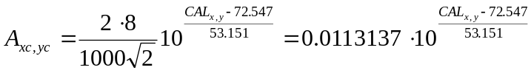 (3.2-7)
where CAL_{x} and CAL_{y} are the calibration amplitudes of X and Y channels.

Re-calibrating
Re-calibration involves amplitude scaling only, and therefore can be expressed simply as
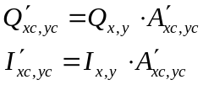 (3.2-8)
The table with the new amplitude correction factors 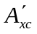and 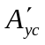 can be found in Appendix C, Table C1-1.

Despinning
The de-spinning procedure (Section 3.1.6) has to be done after the new corrections are applied, using the equations (3.1-2) and the offset time t' from Section 3.2.2.3.

Applying coefficients from the Physical Units Table
The Physical Units Table Each table has coefficients C_{x,y,z}( f, [G] ) in [nV/unit] for all settings of base gain [G] and selected set of frequencies. The table is derived from the Z channel calibration results obtained during the amplitude calibration at [G] = 15 (see description of the calibration in Appendix C and the coefficient values in Table C3-1). The coefficients for other settings of [G] are obtained using the relative gain data shown in Table 3.1-2:
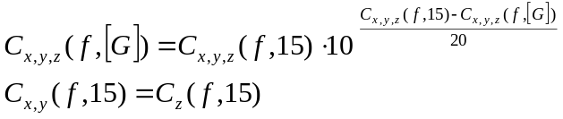 (3.2-9)

Calculations of field strength
The received field strength, E_{R}, is proportional to the antenna voltage, V:
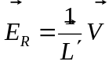 (3.2-10)
where the proportionality factor L' is the effective antenna length, L' ≈ 0.5L_{a}, L_{a} is the tip-to-tip dipole length. The effective antenna lengths are
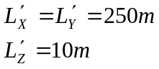 (3.2-11)

Converting thermal noise amplitudes to [ ^{dBVrms}/_{root-Hz} ]
The processing steps to convert thermal noise amplitudes from the raw telemetry representation to [ ^{dBV(rms)}/_{root-Hz} ] are shown in Figure 3.2.2.
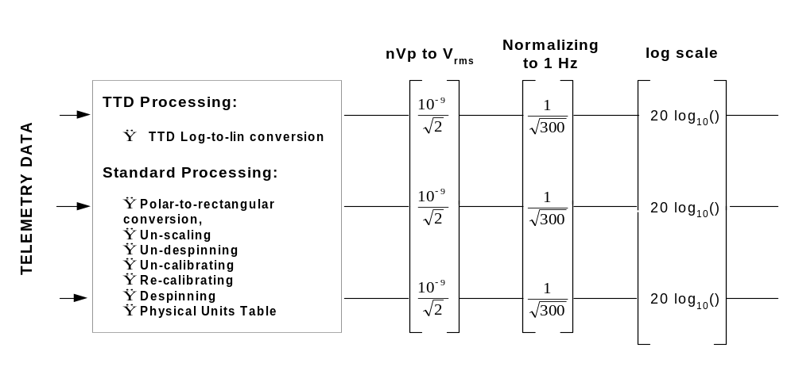
Figure 3.2-14 Physical units conversion for thermal noise data
Logarithmic compression of TTD amplitudes is done differently from the spectral domain data (see Appendix A). To convert TTD amplitudes to the linear scale, the following formula is used:
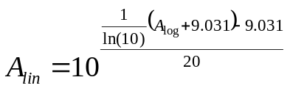 (3.2-12)
Un-scaling, un-calibrating, re-calibrating and conversion to nVp is done the same way it is done for other databins. Then nVp are converted to V_{rms}, and then the thermal noise energy collected over the receiver bandwidth of 300 Hz is normalized to 1 Hz, which corresponds to 1/√300 factor in voltage. Finally, the value is put in dB scale.

Converting phase data to physical units
All phase values given in the RPI data can be converted from 8 bit integer number to 1° units by multiplying them with 360/255.

Converting Doppler bin number to Hz
The coherent integration time is
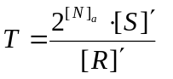, [s] (3.2-13)
[N]_{a} is absolute value of Number of Repetitions
[S]' is the Number of Fine Steps, [S], only if it is a positive value, 1 otherwise
[R]' is Pulse Repetition Rate in pps units; when [R] from Preface is 0, [R]' is 0.5
The Doppler frequency increments are
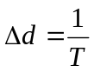, [Hz] (3.2-14)
The Doppler frequencies corresponding to the Doppler bin numbers are listed in Table 4.4-1.
Table 3.2-15 Doppler shift frequency
[N] | Doppler bin numbers | Doppler frequencies, Hz
0 | 1 | N/A
1 | 1-2 | -¹/₂Δd, +¹/₂Δd
2 | 1-4 | -³/₂Δd, -¹/₂Δd, +¹/₂Δd, +³/₂Δd
3 | 1-8 | -⁷/₂Δd, -⁵/₂Δd, …,-¹/₂Δd, +¹/₂Δd,…+⁵/₂Δd, +⁷/₂Δd
4 | 1-16 | -¹⁵/₂Δd, -¹³/₂Δd, …,-¹/₂Δd, +¹/₂Δd,…+¹³/₂Δd, +¹⁵/₂Δd
5 | 1-32 | -³¹/₂Δd, -²⁹/₂Δd, …,-¹/₂Δd, +¹/₂Δd,…+²⁹/₂Δd, +³¹/₂Δd
6 | 1-64 | -⁶³/₂Δd, -⁶¹/₂Δd, …,-¹/₂Δd, +¹/₂Δd,…+⁶¹/₂Δd, +⁶³/₂Δd
7 | 1-128 | -¹²⁷/₂Δd, -¹²⁵/₂Δd, …,-¹/₂Δd, +¹/₂Δd,…+¹²⁵/₂Δd, +¹²⁷/₂Δd

Converting antenna impedance data to physical units
Frequency Header contains six 8-bit values from the antenna impedance measurement:
Table 3.2-16 Antenna impedance data in physical units
Measured characteristic | Physical Units | Conversion Polynomial
Current on X antenna [Ix] | mA | 0.017196*x²+23.697063*x+18.055805
Voltage on +X dipole antenna [V_{x1}] | V(r.m.s) | 0.001041*x³-0.079089*x²+ 6.833423*x+77.628601
Voltage on -X dipole antenna [V_{x2}] | V(r.m.s) | 0.000340*x³-0.072471*x²+10.139749*x+27.581501
Current on Y antenna [Iy] | mA | 0.021766*x²+21.881399*x+15.814330
Voltage on +Y dipole antenna [V_{y1}] | V(r.m.s) | 0.041969*x²+3.503154*x+96.108014
Voltage on =Y dipole antenna [V_{y2}] | V(r.m.s) | 0.039404*x²+3.459442*x+96.996135

RPI Level 0 House Keeping Data Formats
The following sections introduce and describe the formats for housekeeping (HK) data produced by the RPI instrument, which include R_HK Housekeeping package with Build-In Test results, R_SRD Segment Report package containing the contents of RPI SRAM segments, R_MSG Software Message package containing software generated message, and R_ECH Command Echo package with a copy of the latest ground command.

(R_HK) House Keeping data sets. ApID = 0x02
The RPI house keeping represents the RPI health and safety data package. The R_HK package is generated by RPI to report on system (hardware and software) status. The package is sent periodically (nominally every 10 minutes) or by request from the ground. The structure of the data block is given in sections 5.1 to 5.6. Each section describes part of the data block that is given by the overview in Table 5.0-1.
Table 4.0-17 RPI House Keeping data format
 | R_HK Block
Sec_2.1 | Sec_5.1 | Sec_5.2 | Sec_5.3 | Sec_5.4 | Sec_5.5 | Sec_5.6 | Sec_2.5
Data  Package  Preamble | HK  Header | Misc. status info | Digital  Sensors | Analog  Sensors | NoGo Table | Power Limits | Checksum

Housekeeping Header
Housekeeping Header format is identical to all four HK packages (R_HK, R_SRD, R_MSG, and R_ECH). It contains five items, as shown in Table 5.1-1.
Table 4.1-18 HK Header
Byte  Count  Offset | Byte  Offset  No | Byte  Length | Description | Units | Range
7 | 0 | 1 | Package ApID | N/A | N/A
8 | 1 | 1 | Software version | N/A | 0-255
9..12 | 2..5 | 4 | CIDP MET stamp | 0.1 sec | 0 to 4294967296
13..16 | 6..9 | 4 | RPI MET stamp | 0.1 sec | 0 to 4294967296
17..18 | 10..11 | 2 | Argument of perigee | LSB=5.5*10⁻³ | 0 to 360

Package ApID is preserved for data identification purpose outside the standard data archive environment. Software version is reported for backward compatibility in case of design changes. CIDP and RPI time stamps are given for the clock comparison purpose. Orbital position phase is given to verify calculation algorithm.

Miscellaneous status information
This section contains various status information items listed in Table 5.2-1.
Table 4.2-19 Miscellaneous status information
Byte  Count  Offset | Byte  Offset  No | Byte  Length | Description | Units | Range
19..22 | 0 | 4 | Last SST in the SST Queue | 0.1 sec | 0 to 4294967296
23 | 4 | 1 | Memory checksum failure | N/A | 0..1, 1 -failed
24 | 5 | 1 | Program status (format variable) | N/A | 0-255
25 | 6 | 1 | Communication Status (from serial port UART) | N/A | 0-255

Digital Sensor Readings
This section contains digital sensor readings in accordance with the state of digital I/O lines on the BIT card.
Table 4.3-20 Digital sensor readings
Byte  Count  Offset | Byte  Offset  No | Byte  Length | Description | Units | Range
26 | 0 | 1 | Digital sensor readings | N/A | 0-255

Each bit of the status byte signifies if reading is valid or not valid. The actual bit readings need to be compared against the expected "Go" value to correctly interpret the result. This comparison is done onboard to fill the NoGo Table where 1 always indicates "NoGo" (and 0 indicates "Go").
The Digital Sensors names and "Go" condition are listed in Table 5.3-2. The following categories of signals are monitored:
- 16MHz RPI master 16 MHz oscillator signal
- Vc Antenna coupler voltages +12 and +24V
- V DC -5, -15 and +15V

Table 4.3-21 Digital Sensor Readings
 | D7 | D6 | D5 | D4 | D3 | D2 | D1 | D0
Signal name | - | 16 MHz | +24 Vc | - | +12Vc | -5V | -15 V | +15 V
GO condition | - | 1 | 1 | - | 1 | 0 | 0 | 1

Go conditions for digital sensors are specified in the onboard ARMENU control structure, question 351 (see RPI Commanding document, Section 2).

Analog Sensor Readings
This section contains the measurements from the analog input channels on the BIT card. The values are 16 bit integers with 12 bits containing raw value from the ADC.
Table 4.4-22 Analog sensor readings
Byte  Count  Offset | Byte  Offset  No | Byte  Length | Description | Type | Units | Range
27..28 | 0..1 | 2 | Channel.00 Xmtr Xb | B | 5/4096 V | 0-2.5 V
29..30 | 2..3 | 2 | Channel.01 Xmtr Yb | B | 5/4096 V | 0-2.5 V
31..32 | 4..5 | 2 | Channel.02 1st Lob | B | 5/4096 V | 0-2.5 V
33..34 | 6..7 | 2 | Channel.03 SysTemp | S | 5/4096 V | 0-2.5 V
35..36 | 8..9 | 2 | Channel.04 500 kb | B | 5/4096 V | 0-2.5 V
37..38 | 10..11 | 2 | Channel.05 3.84 Mb | S | 5/4096 V | 0-2.5 V
39..40 | 12..13 | 2 | Channel.06 95 kb | S | 5/4096 V | 0-2.5 V
41..42 | 14..15 | 2 | Channel.07 X+Tmp | B | 5/4096 V | 0-2.5 V
43..44 | 16..17 | 2 | Channel.08 X-Tmp | B | 5/4096 V | 0-2.5 V
45..46 | 18..19 | 2 | Channel.09 Y+Tmp | S | 5/4096 V | 0-2.5 V
47..48 | 20..21 | 2 | Channel.10 Y-Tmp | S | 5/4096 V | 0-2.5 V
49..50 | 22..23 | 2 | Channel.11 Ztmp | S | 5/4096 V | 0-2.5 V
51..52 | 24..25 | 2 | Channel.12 RFX+ | B | 5/4096 V | 0-2.5 V
53..54 | 26..27 | 2 | Channel.13 RFX- | B | 5/4096 V | 0-2.5 V
55..56 | 28..29 | 2 | Channel.14 RFY+ | B | 5/4096 V | 0-2.5 V
57..58 | 30..31 | 2 | Channel.15 RFY- | B | 5/4096 V | 0-2.5 V
59..60 | 32..33 | 2 | Channel.16 RFSmpZ | B | 5/4096 V | 0-2.5 V
61..62 | 34..35 | 2 | Channel.17 RFSmpX | B | 5/4096 V | 0-2.5 V
63..64 | 36..37 | 2 | Channel.18 IFSmpZ | B | 5/4096 V | 0-2.5 V
65..66 | 38..39 | 2 | Channel.19 IFSmpY | B | 5/4096 V | 0-2.5 V
67..68 | 40..41 | 2 | Channel.20 2500 b | S | 5/4096 V | 0-2.5 V
69..70 | 42..43 | 2 | Channel.21 400 kb | S | 5/4096 V | 0-2.5 V
71..72 | 44..45 | 2 | Channel.22 XvarI | B | 5/4096 V | 0-2.5 V
73..74 | 46..47 | 2 | Channel.23 YvarI | B | 5/4096 V | 0-2.5 V
75..76 | 48..49 | 2 | Channel.24 YvarV | B | 5/4096 V | 0-2.5 V
Type B = Burst measurement of a pulse signal must be done during sounding only.
Type S = Single measurement of a continuous signal may be done anytime.

NoGo Table
This section contains 5 bytes indicating Go/NoGo condition of all sensor readings. Each bit of the NoGo Table bytes is set to 1 (NoGo) if:
- analog sensor reading is outside the onboard red tolerance limits or digital sensor reading is not GO (see Table 5.2-2), and
- the sensor is specified as capable of generating NoGo condition.
Onboard red limits are specified in questions 330-343 of the ARMENU control structure (see RPI Commanding document, section 2.1), GO conditions of digital sensors are given in question 351 of the ARMENU structure, and sensors capable of generating NoGo condition are listed in questions 361-365.
Table 4.5-23 NoGo Table
Byte  Count  Offset | Byte  Offset  No | Byte  Length | Description | Units | Range
77 | 0 | 1 | Digital Sensor | N/A | 0-255
78 | 1 | 1 | Analog Status : Ch00-Ch07 | N/A | 0-255
79 | 2 | 1 | Analog Status : Ch08-Ch15 | N/A | 0-255
80 | 3 | 1 | Analog Status : Ch16-Ch23 | N/A | 0-255
81 | 4 | 1 | Analog Ch24 and Reserved Bits | N/A | 0-255

The Digital and Analog sensor flags and their associated reading parameters are listed in Table 5.5-2.
Table 4.5-24 Digital and Analog sensor flag parameters
Line  Count | Category | D7 | D6 | D5 | D4 | D3 | D2 | D1 | D0
0 | Byte 1 digital | - | 16 MHz | +24 Vc | - | +12Vc | -5V | -15 V | +15 V
4 | Ch00-Ch07 analog. | XMTR 1 | XMTR 2 | 1st LO | SysTemp | C140K | 3.84MHz | 95kHz | X+tmp
5 | Ch08-Ch15 analog. | X-tmp | Y+tmp | Y-tmp | Ztmp | RFX+ | RFX- | RFY+ | RFY-
6 | Ch16-Ch23 analog. | RFSmpZ | RFSmpX | IFSmpZ | IFSmpX | 2500 Hz | 400 kHz | XvarI | YvarI
7 | Reserved | XyvarV | Reserved

RPI Power Limits
If necessary, PRI can be instructed to use power limit different from the limit specified in the measurement programs (see program parameter 11(W) in the Preface, Section 2.3). There is a pass-through command R_SYS_PLIM_SET that specifies Peak and Average power limits. Before running a program, RPI evaluates all available limits, and selects the minimum.
The following section of HK package reports current settings of peak and average power limits as instructed from the ground.
Table 4.6-25 Peak and Average Power Limits
Byte  Count  Offset | Byte  Offset  No | Byte  Length | Description | Units | Range
82 | 0 | 1 | Peak Power Limit | Watts | 0-255
83 | 1 | 1 | Average Power Limit | Watts | 0-255

(R_SRD) Segment Report data set. ApID=0x04
This report segment is generated by RPI in response to the ground request R_MEM_DATA_SEND, which instructs RPI to downlink a specific segment of memory from the RPI CPU. The segment can be a section of the flight software or one of the control data structures (Programs, Schedules, SST Tables, ARMENU). The structure of the Segment Report package is given in Table 6.0-1.
Table 5.0-26 RPI Segment Report data format
 | RPI-SRD Block
Sec_2.1 | Sec_5.1 | Sec_6.1 | Sec_2.4
Data Package  Preamble | HK  Header | Segment data | Checksum

Segment Data
The segment data are stored in accordance to the format described in Table 6.1-1.
Table 5.1-27 Segment Data
Byte Count  Offset | Byte  Offset No | Byte  Length | Description | Units | Range
19..20 | 0..1 | 2 | SCLen Segment length | N/A | 0-65536
21..24 | 2..5 | 4 | Segment Address | 32 bit words | 0-0x00FFFFFF
25..SCLen*4+25 | 3..SCLen*4+3 | SCLen*4 | Segment Contents | N/A | N/A

(R_MSG) Software Message. ApID=0x06
When a software fault is detected, a R_MSG software message package is generated. The message contains a message code (associated with a table for identification of the problem type), and two message parameters. The structure of the Software Message package is given in Table 7.0-1.
Table 6.0-28 RPI Segment Report data format
 | RPI-MSG Block
Sec_2.1 | Sec_5.1 | Sec_7.1 | Sec_2.4
Data Package  Preamble | HK  Header | Software message | Checksum

Software Message
Table 6.1-29 Software message
Byte Count  Offset | Byte Offset | Byte  Length | Description | Units | Range
19 | 0 | 1 | Message Code | Table 7.1-2 | 0-255
20..23 | 1..4 | 4 | Message Parameter #1 | Table 7.1-2 | Message dependent
24..27 | 5..8 | 4 | Message Parameter #2 | Table 7.1-2 | Message dependent

Message codes and the associated parameters are listed in Table 7.1-2.

Table 6.1-30 Message Codes and Parameters
Message  Code |  | Message Code Description | Message Parameters Description
202 | 0xCA | CIT start timeout | #1 -- Timeout, sec
203 | 0xCB | Pulse start timeout | #1 -- Timeout, sec
204 | 0xCC | Prerun condition timeout | #1 -- Timeout, sec
205 | 0xCD | Blank command parameter | #1 -- Command stem
207 | 0xCF | No timing port signal
208 | 0xD0 | No 1_PPS signal
209 | 0xD1 | No Clock Pulse signal
210 | 0xD2 | Digitizer timeout | #1 -- Timeout, sec
211 | 0xD3 | EEPROM load error
212 | 0xD4 | EEPROM save error | #1 -- Address, 32 bit
213 | 0xD5 | Data upload checksum error | #1 -- Checksum, 8 bit
214 | 0xD6 | Bad command stem | #1 -- Command stem
215 | 0xD7 | System is not in HiPower to execute command
216 | 0xD8 | Communications: Unknown Error
217 | 0xD9 | Communications: Framing Error
218 | 0xDA | Communications: Sync. Byte Error
219 | 0xDB | Communications: Bad Command Message Checksum
220 | 0xDC | Communications: Bad Command Message Header
221 | 0xDD | Communications: Bad Command Stem
222 | 0xDE | Communications: Bad Upload Checksum
223 | 0xDF | Communications: Bad Upload Address
224 | 0xE0 | Communications: Command Queue Overflow
225 | 0xE1 | SST Queue Overflow
226 | 0xE2 | SST Queue Error: MET Already Active
227 | 0xE3 | SST Queue Error: MET already passed
228 | 0xE4 | Bad CIDP Data Block Number in Data Load Request
229 | 0xE5 | Lost Sync. Pulse (Delphi)

(R_ECH) Command Echo. ApID=0x08
Every command sent to RPI has a corresponding RPI_ECHO package sent back as an acknowledgement. The structure of the Software Message package is given in Table 8.0-1.
Table 7.0-31 RPI Command Echo format
 | R_ECH Block
Sec_2.1 | Sec_5.1 | Sec_8.1 | Sec_2.4
Data Package  Preamble | HK  Header | Command Replica | Checksum

Command Replica
Table 7.1-32 Command Replica
Byte  Count  Offset | Byte  Offset  No | Byte  Length | Description | Units | Range
19 | 0 | 1 | Command stem | N/A | 0-255
20..23 | 1 | 4 | Command action Parameter 1 | N/A | Command specific
24..27 | 5 | 4 | Command action Parameter 2 | N/A | Command specific

RPI Development Package Formats
The following sections introduce and describe the formats for development data packages produced by the RPI instrument in response to debugging commands.

Development Package Formats
RPI responds to certain development commands by outputting Development Package(s) to the RS-422 port (to be received by CIDP, GSEOS, ASIST, etc.). All development packages are formatted as standard Science Data Packages, however, they are unlikely to be used during the mission time.

ApID=0x1F Frequency Set Response Package
The frequency set command R_DEB_FREQ_SET is acknowledged by a message giving the programmed frequency, the coupler mode character, the relay settings for all four couplers, the synthesizer control byte settings, and the preselector control byte setting (see Table 9.1-1).
Table 8.1-33 Frequency Set Response package, ApID=0x1F
Byte No. | Name | Value | Comments
0..2 | Sync pattern | FEFA30h
3 | Header | 0xDC | Data package
4 | ApID | 0x1F
5..6 | Byte Count | 21 | (constant)
7-10 | Frequency | f<31:24>
 |  | f<23:16> | Sounding frequency in Hz.
 |  | f<15:8>
 |  | f<7:0>
11 | Coupler mode | ‘N’ - normal  ‘D’ - direct  ‘C’ - calibrate  ‘S’ - calibrate-direct | This character indicates whether a special coupler mode has been selected.
12..13 | Xplus relays | <15:8>  <7:0> | This 16-bit value indicates the states of the 16 relays in this antenna coupler. Bit zero equals 1 if relay K1 is on; bit 1 is 1 for relay K2, etc.
14..15 | Xminus relays | <15:8>  <7:0> | This 16-bit value indicates the states of the 16 relays in this antenna coupler. Bit zero equals 1 if relay K1 is on; bit 1 is 1 for relay K2, etc.
16..17 | Yplus relays | <15:8>  <7:0> | This 16-bit value indicates the states of the 16 relays in this antenna coupler. Bit zero equals 1 if relay K1 is on; bit 1 is 1 for relay K2, etc.
18..19 | Yminus relays | <15:8>  <7:0> | This 16-bit value indicates the states of the 16 relays in this antenna coupler. Bit zero equals 1 if relay K1 is on; bit 1 is 1 for relay K2, etc.
20 | Reg5 |  |  | LO freq = Reg5*125 kHz
21 | Reg4 |  | Synth. | + Reg4*125 khz / 2⁸
22 | Reg3 |  | Control | + Reg3*125 kHz / 2¹⁶
23 | Reg2 |  | Registers | + Reg2*125 kHz / 2²⁴
24 | Reg1 |  |  | + Reg1*125 kHz / 2³²
25 | Reg0 |  |  | + Reg0*125 kHz / 2⁴⁰
26 | Data Byte “n” | pfrq | Preselector control byte
27 | Checksum |  | xor sum bytes 7-26

ApID=0x2F Memory Read/Write Response Package
The memory read/write command reply gives the starting and ending addresses of the memory block followed by the contents of the block. The format for the memory read/write command reply message is given in Table 9.2-1.
Table 8.2-34 Memory Read/Write Response package, ApID=0x2F
Byte No. | Name | Byte Value | Comments
0..2 | Sync pattern | FEFA30h
3 | Header | 0xDC | Data package
4 | ApID | 0x2F
5..6 | Byte Count |  | Byte Cnt = 10 + 4*(Addr2-Addr1+1)
7 | Data Byte 0 | ‘R’ or ‘W’ | ‘R’ = memory block read,  ‘W’ = memory block write
8..11 | Starting Address | <31:24>  <23:16>  <15:8>  <7:0> | Starting address of memory block to be read/written
12..15 | Ending Address | <31:24>  <23:16>  <15:8>  <7:0> | Ending address of memory block to be read/written
16..19 | Data 1 | <31:24>  <23:16>  <15:8>  <7:0> | 32 bit word
… | … | … | …
15+4*n |  | Checksum | xor sum bytes 7-19

ApID=0x3F VME Read/Write Response Package
The VME Read/Write response package returns the VME address and contents for the affected VME port. The format for the VME read/write command reply message is given in Table 9.3-1.
Table 8.3-35 VME Read/Write Response package, ApID=0x3F
Byte No. | Name | Byte Value | Comments
0..2 | Sync pattern | FEFA30h
3 | Header | 0xDC | Data package
4 | ApID | 0x3F
5..6 | Byte Count | 6
7..10 | Address | <31:24>  <23:16>  <15:8>  <7:0> | VME Address of affected VME port..
11 | Value |  | Contents of affected VME port after VME Port command is executed.
12 | Checksum |  | xor sum bytes 7-11

ApID=0x4F Digitizer Samples Package
The R_DEB_DGTZ_GET command continuously takes digitizer samples, sending back digitizer sample blocks as indicated below. Packages are transmitted continuously until RPI receives a new command. The format for the Digitizer Samples package is shown in Table 9.4-1.
Table 8.4-36 Digitizer Sample package, ApID=0x4F
Byte No. | Name | Byte Value | Comments
0..2 | Sync pattern | FEFA30h
3 | Header | 0xDC | Data package
4 | ApID | 0x4F
5..6 | Byte Count | 4N+1 | N = number of complex samples
7..8 | Real 1 | <15:8>  <7:0> | First real sample
9..10 | Imaginary 1 | <15:8>  <7:0> | First imaginary sample
11..12 | Real 2 | <15:8>  <7:0> | Second real sample
13..14 | Imaginary 2 | <15:8>  <7:0> | Second imaginary sample
… | … | … | …
 | Real N | <15:8>  <7:0> | Nth real sample
 | Imaginary N | <15:8>  <7:0> | Nth imaginary sample
4N+6 | Checksum |  | xor sum

Appendix A. Thermal Noise Data Processing
Since lots of effort has been put into making standard reusable tools for operational software and data analysis software we would like to find a way to structure the TTD output telemetry packages to use the DataBin format (i.e. General header, preface, data header, frequency header and data block). In order to force TTD data into this DataBin file handling convention without paying too dearly in storage efficiency, we have defined a standard TTD mode of operation, making N=3 the minimum value allowed. This ensures that we have at least 32 time domains samples per frequency step. Note, that for standard sounder modes, all of these values correspond to samples after a single pulse. However, the TTD mode is a Receive Only mode, so there is no transmitted pulse, but there is still a logic pulse that triggers the digitizer to make a one-dimensional sample array of 32 to 1024 samples at each frequency step. The elements of the DataBin are 8-bit Logarithmic amplitudes, 8-bit cross-power log ampliltudes, and the corresponding cross-power phase arguments also in an 8-bit format (0-359 deg in 1.4deg steps). The algorithm for computing these out of 36 samples (S₀ to S₃₅) on each of three antennas (Sx₀ to Sx_{35;} Sy₀ to Sy_{35;} Sz₀ to Sz₃₅₎ is:

Calculating Log Amplitudes
Compute a power term for each complex sample from Receiver X,
P_{x} = Re² + Im² (A-1)
Note that the power term is always positive, so we can add without concern that the amplitude of the sum may be cancelled out by anti-phased signals. Therefore, sum the first 8 contiguous powers,
8P_{x} = ∑ P_{i} , for i = 0 to 7 (A-2)
Now make the log of the average positive power term:
A_{x} = 10 log (8P_{x}) - 9.031 (A-3)
where the -9.031 divides the power by a factor of 8, thus forming the first average, A_{x}[0]. Now move the starting point up 4 samples, and create a new 8-point average which overlaps half the data used in the previous average. Continue up until sample 28 to 35 are used in making the eighth average, the final amplitude stored in the data bin. Store A_{x}[0] to A_{x}[7] in the databin.
Repeat for A_{y}[0-7] and A_{z}[0-7].

Calculating Cross Power Terms (XY, XZ and YZ)
Using all 36 samples, compute a cross-power for each pair of complex samples,
P_{xy} = (Re(S_{xi}) + j Im(S_{xi})) * (Re(S_{yi}) - j Im(S_{yi})) (A-4)
which are sampled simultaneously from antenna X &Y, or X & Z or Y & Z, then coherently sum (actually average by dividing by 36) the 36 complex products. Conjugating the Y samples gives the cross-power vector a phase equal to the phase difference between the X axis and Y axis sample. Since the signals have the receiver calibration corrections as well as the spin-phase rotation correction already performed, the X Y and Z signal components are already lined up with the RPI coordinate system, and the combined amplitude of the cross-products is representative of the real E-field strengths.
Real(Sum) = Σ (Real(S_{i}) / 36) for i = 0 to 35, and (A-5)
Imag(Sum) = Σ (Imag(S_{i}) / 36) for i = 0 to 35

Note: These power terms need not be positive numbers, but since they are already powers (not amplitudes) we have to compute a resultant vector using sqrt(Re² + Im²) in order to express the magnitude of the cross-power in dB.
Mag|CXY| = (sqrt( (Real(Sum))² + (Imag(Sum)) ² ) (A-6)
And in dB,
CXY Power = 10 log (Mag|CXY|) (A-7)

Calculating Cross Phases (XY, XZ and YZ)
Phase CXY uses the cross-power vector components Re(Sum) and Im(Sum)
PhaseCXY = tan⁻¹ (Im(Sum)/Re(Sum)), [range -180deg to +179deg] (A-8)
And the conversion to 8-bit phase is,
CXY Phase = (256/360) (PhaseCXY+180) (A-9)

Appendix B. Coupler Band Center Frequency Table

Index | Frequency, kHz | Index | Frequency, kHz | Index | Frequency, kHz
0 | 3.000 | 46 | 45.600 | 92 | 193.500
1 | 9.500 | 47 | 47.150 | 93 | 195.000
2 | 9.900 | 48 | 48.700 | 94 | 195.750
3 | 10.200 | 49 | 51.600 | 95 | 198.000
4 | 10.450 | 50 | 54.500 | 96 | 200.000
5 | 10.800 | 51 | 56.025 | 97 | 205.000
6 | 11.150 | 52 | 57.550 | 98 | 220.000
7 | 11.600 | 53 | 59.425 | 99 | 233.000
8 | 11.950 | 54 | 61.300 | 100 | 259.000
9 | 12.500 | 55 | 63.325 | 101 | 308.000
10 | 13.100 | 56 | 65.350 | 102 | 320.000
11 | 13.500 | 57 | 68.300 | 103 | 380.000
12 | 13.750 | 58 | 72.700 | 104 | 440.000
13 | 14.300 | 59 | 74.550 | 105 | 496.000
14 | 14.750 | 60 | 76.400 | 106 | 535.000
15 | 15.350 | 61 | 78.850 | 107 | 575.000
16 | 15.800 | 62 | 81.200 | 108 | 605.000
17 | 16.500 | 63 | 84.900 | 109 | 630.000
18 | 17.350 | 64 | 86.000 | 110 | 653.000
19 | 17.900 | 65 | 89.800 | 111 | 685.000
20 | 18.300 | 66 | 97.400 | 112 | 760.000
21 | 18.950 | 67 | 100.500 | 113 | 870.000
22 | 19.600 | 68 | 102.500 | 114 | 904.000
23 | 20.400 | 69 | 105.000 | 115 | 973.000
24 | 21.000 | 70 | 108.000 | 116 | 1190.000
25 | 21.950 | 71 | 111.500 | 117 | 1220.000
26 | 23.000 | 72 | 114.000 | 118 | 1280.000
27 | 23.700 | 73 | 118.200 | 119 | 1320.000
28 | 24.150 | 74 | 134.500 | 120 | 1510.000
29 | 25.050 | 75 | 137.500 | 121 | 1600.000
30 | 25.900 | 76 | 139.750 | 122 | 2000.000
31 | 26.900 | 77 | 143.500 | 123 | 3000.000
32 | 27.700 | 78 | 146.000
33 | 28.900 | 79 | 149.500
34 | 30.600 | 80 | 151.500
35 | 31.600 | 81 | 154.500
36 | 32.300 | 82 | 172.000
37 | 33.500 | 83 | 174.000
38 | 34.500 | 84 | 175.500
39 | 35.900 | 85 | 177.000
40 | 37.000 | 86 | 180.000
41 | 38.700 | 87 | 182.500
42 | 40.400 | 88 | 185.000
43 | 41.600 | 89 | 186.000
44 | 42.550 | 90 | 190.500
45 | 44.075 | 91 | 192.000

Appendix C. Calibration Procedures

Phase calibration procedure
Phase calibration was done at SwRI labs by feeding a known generator signal into three receivers set at G=15, as shown on Figure C1-1.
Figure C1-15 Phase calibration setup with HP synthesizer
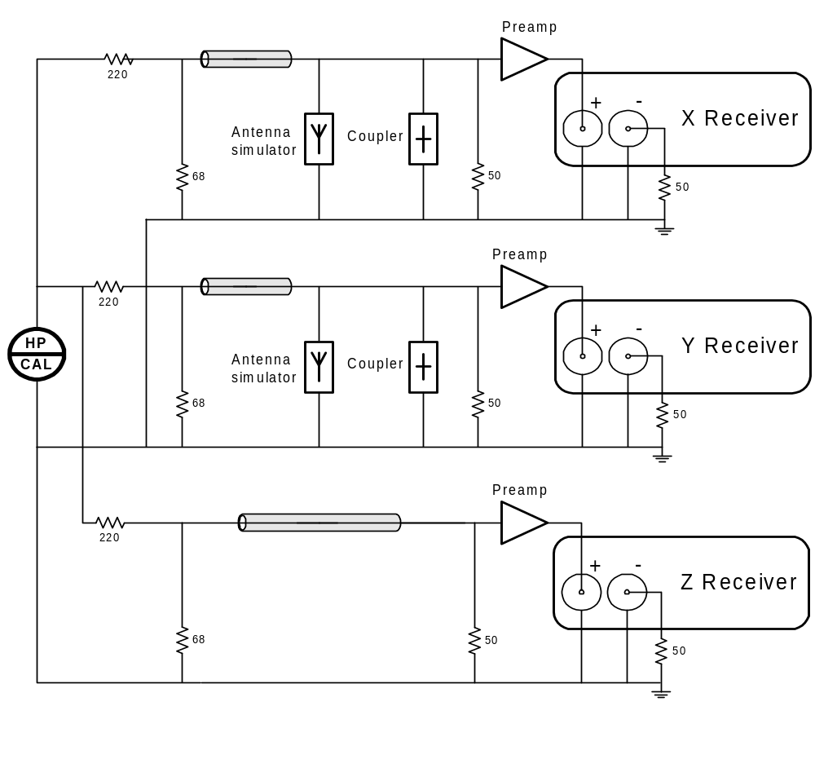
The output of each receiver was sampled twice, to capture I and Q quadrature components spaced 90° apart. The ratio of Z channel output to X and Y channels comprises the default calibration table.

Onboard calibration procedure
Onboard calibration procedure is done by feeding identical calibration signals to the receivers on each frequency before the actual transmission is made, as shown in Figure C2-1. The calibration signal is applied directly to the couplers at the base of the X and Y antennas; however, the Z channel is calibrated without the wide-band pre-amplifiers whose gain is assumed equal to 12 dB (LoGain setting) and phase contributions are assumed constant for the mission period. The amplitude of the calibration signals is always the same and is selected optimally to obtain good receiver responses with any setting of their gain.
The receiver response to the calibration signals is used onboard to introduce corrections to the X and Y channel data that equalize their phase and gain characteristics with the Z channel. It is important to make +12 dB corrections to the X and Y data on the ground if HiGain setting was used for the Z preamplifier. With this correction introduced, RPI data can be directly used to derive the angles of arrival. An additional effort is required to convert the observed amplitudes to the physical units, [^{nV}/_{m}], as discussed in Section 3.2.1.

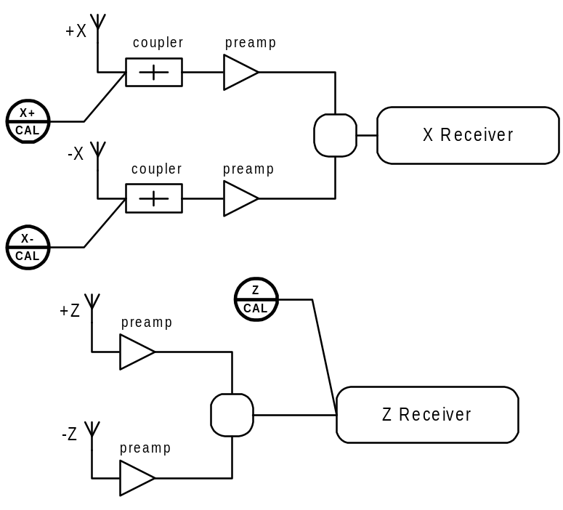
Figure C2-16 Application of calibration signals to X(Y) and Z receiver channels

Amplitude calibration procedure
Amplitude calibration was done at SwRI labs by feeding a known generator signal into receiver as shown on Figure C3-1.
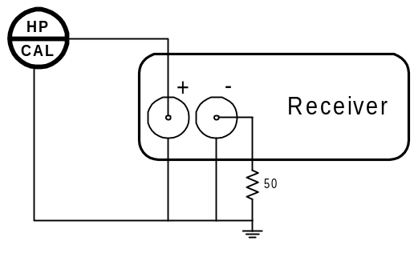Figure C3-17 Amplitude calibration setup with HP synthesizer

Input voltage calculation
The generator input was originally expressed in [dBm into a 50 ohm load]. The following considerations are used to express the input voltage in [Vp]:
- dBm units are referenced to 1 mW of power on 50 ohm load
- Voltage corresponding to 1 mW on 50 ohm is:
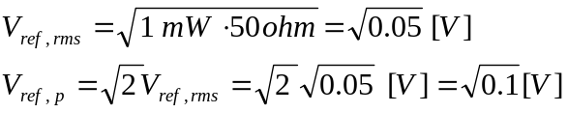
- For D dBm the generator output voltage is
V_{g-out,p} = V_{ref, p} *10^{(D/20)} = 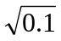*10^{(D/20)} [V]
To account for the fact that the calibration setup (Figure C1-1) is different from the operational RPI setup where both dipole elements feed the receiver, 6 dB are subtracted from the test source power. Another 6 dB are subtracted to account for the losses in the 3 way splitter. Thus, the input voltage for this test is
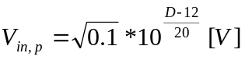
To obtain the value of receiver sensitivity in volts per digitizer unit, S_{du,p}(f), from the amplitude calibration data, the following formula is used:
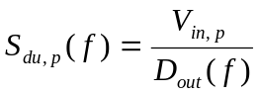 [V/unit],
where D_{out}(f) are the amplitudes [in digitizer units] and V_{in,p} is the peak voltage in [V].

Amplitude calibration coefficients
Ratio of Z channel amplitudes to X and Y channel amplitudes gives the correction coefficients and for the re-calibration procedure described in Section 3.2.2.6. The coefficients are given in the Table C3-1.

Physical Units table
Figure C3-1 shows graph of the Z channel zero-to-peak voltage per digitizer unit, in [nV/unit], which is used for conversion of the amplitudes to physical units in Section 3.2.2.8.
Figure C3-18 Z channel voltage per digitizer unit, [nV].

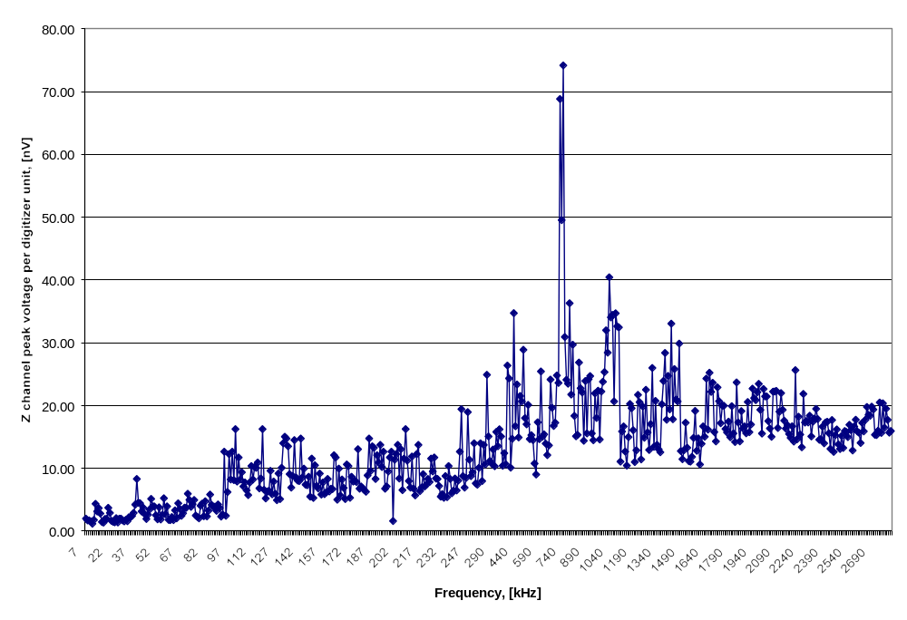The gains of the X and Y channels are matched to the gain of the Z receiver during onboard calibration (see Section 3.1.2) so that, for the purpose of conversion to physical units, X and Y digitizer unit values are not used. The zero-to-peak voltage [in nV] per digitizer units for Z channel are given in Table C3-1. Section 3.2.2.3 explains how to use these coefficients to derive the Physical Units table for all channels and all settings of the base gain.
Table C3-37 X/Y Amplitude Corrections and Physical Units table.
Frequency[kHz] | Correction coefficient | Correction coefficient 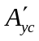 | Voltage per digitizer unit  [nVp]
7 | 36.786 | 34.606 | 1.971
8 | 32.217 | 27.144 | 1.691
9 | 21.343 | 17.426 | 1.712
10 | 20.693 | 36.123 | 1.549
11 | 26.149 | 44.490 | 1.168
12 | 20.990 | 24.373 | 1.777
13 | 9.402 | 13.094 | 4.328
14 | 15.622 | 18.961 | 3.123
15 | 13.994 | 12.361 | 3.653
16 | 11.783 | 8.955 | 2.784
17 | 33.190 | 17.836 | 1.448
18 | 22.553 | 42.523 | 1.343
19 | 17.918 | 15.358 | 1.933
20 | 16.976 | 31.871 | 1.961
21 | 6.800 | 21.410 | 3.704
22 | 17.677 | 16.946 | 2.885
23 | 17.989 | 19.127 | 1.632
24 | 13.724 | 37.506 | 1.466
25 | 19.310 | 49.934 | 1.404
26 | 13.823 | 30.128 | 2.058
27 | 23.085 | 52.569 | 1.368
28 | 14.056 | 60.605 | 1.991
29 | 18.772 | 57.071 | 1.976
30 | 45.052 | 81.761 | 1.694
31 | 17.635 | 103.667 | 1.546
32 | 31.611 | 50.388 | 1.781
33 | 34.732 | 62.367 | 1.564
34 | 20.254 | 36.133 | 2.218
35 | 19.757 | 21.180 | 2.212
36 | 18.400 | 19.822 | 2.398
37 | 26.678 | 19.183 | 2.896
38 | 7.088 | 19.022 | 4.213
39 | 6.840 | 10.953 | 8.295
40 | 15.872 | 16.209 | 4.524
41 | 9.065 | 18.823 | 4.449
42 | 27.071 | 17.596 | 3.110
43 | 18.585 | 11.252 | 3.721
44 | 24.816 | 12.849 | 2.699
45 | 28.564 | 18.269 | 1.937
46 | 14.459 | 18.870 | 2.619
47 | 20.235 | 11.917 | 3.418
48 | 9.354 | 9.119 | 5.137
49 | 23.868 | 32.905 | 3.942
50 | 21.188 | 19.133 | 3.923
51 | 12.420 | 36.054 | 2.520
52 | 29.292 | 19.059 | 1.887
53 | 8.975 | 8.446 | 3.774
54 | 22.224 | 28.051 | 1.856
55 | 17.610 | 11.222 | 2.577
56 | 11.562 | 6.374 | 5.239
57 | 29.261 | 22.636 | 2.672
58 | 21.563 | 22.680 | 3.942
59 | 25.213 | 59.568 | 1.785
60 | 45.268 | 35.479 | 1.742
61 | 15.244 | 45.731 | 2.230
62 | 24.538 | 48.890 | 1.739
63 | 13.188 | 30.593 | 3.304
64 | 35.684 | 33.205 | 2.042
65 | 9.342 | 11.769 | 4.424
66 | 11.581 | 16.730 | 3.539
67 | 17.590 | 36.974 | 2.428
68 | 15.297 | 22.594 | 2.854
69 | 11.875 | 17.102 | 3.738
70 | 25.838 | 25.037 | 3.704
71 | 10.403 | 12.801 | 5.942
72 | 22.157 | 12.810 | 4.977
73 | 30.716 | 27.777 | 3.865
74 | 14.420 | 18.720 | 4.281
75 | 8.577 | 17.863 | 4.946
76 | 13.445 | 30.042 | 2.465
77 | 22.596 | 41.567 | 2.249
78 | 49.523 | 29.462 | 2.037
79 | 14.400 | 11.364 | 4.022
80 | 16.653 | 10.077 | 4.375
81 | 34.891 | 39.038 | 2.356
82 | 18.386 | 9.488 | 4.740
83 | 25.315 | 39.431 | 2.342
84 | 15.746 | 23.405 | 3.250
85 | 18.788 | 15.823 | 5.812
86 | 40.319 | 18.063 | 4.169
87 | 43.113 | 19.452 | 3.884
88 | 39.570 | 34.594 | 3.884
89 | 19.636 | 33.790 | 3.224
90 | 25.350 | 14.358 | 4.236
91 | 3.019 | 29.121 | 3.670
92 | 25.115 | 33.200 | 2.315
93 | 21.976 | 37.368 | 2.645
94 | 8.724 | 10.383 | 12.639
95 | 63.335 | 93.084 | 2.435
96 | 29.208 | 34.685 | 6.221
97 | 19.591 | 26.168 | 12.251
98 | 32.935 | 33.748 | 8.209
99 | 34.474 | 15.712 | 12.639
100 | 27.344 | 24.015 | 8.125
101 | 13.214 | 9.863 | 16.251
102 | 23.919 | 16.358 | 7.884
103 | 12.607 | 12.284 | 11.710
104 | 17.867 | 19.526 | 8.209
105 | 16.077 | 10.988 | 9.368
106 | 16.228 | 13.966 | 7.110
107 | 12.299 | 14.229 | 7.731
108 | 15.828 | 14.383 | 6.474
109 | 25.354 | 17.031 | 5.729
110 | 17.699 | 17.278 | 7.731
111 | 16.565 | 14.466 | 10.341
112 | 12.685 | 10.554 | 8.209
113 | 14.753 | 10.991 | 10.209
114 | 10.074 | 14.180 | 10.080
115 | 11.926 | 7.943 | 10.908
116 | 21.001 | 12.682 | 6.806
117 | 20.359 | 10.752 | 8.382
118 | 6.305 | 9.523 | 16.251
119 | 16.798 | 26.434 | 6.581
120 | 23.307 | 16.712 | 5.204
121 | 19.995 | 12.782 | 6.270
122 | 23.611 | 15.531 | 6.422
123 | 18.062 | 16.589 | 9.594
124 | 17.703 | 21.532 | 5.855
125 | 9.714 | 8.704 | 7.884
126 | 14.386 | 22.749 | 5.942
127 | 25.434 | 18.045 | 4.915
128 | 17.767 | 15.616 | 9.153
129 | 28.002 | 24.155 | 5.104
130 | 8.663 | 9.238 | 10.080
131 | 6.312 | 6.178 | 13.970
132 | 6.728 | 9.394 | 15.024
133 | 6.933 | 7.804 | 14.746
134 | 7.136 | 6.298 | 13.496
135 | 17.465 | 19.682 | 9.049
136 | 13.504 | 11.332 | 6.924
137 | 15.085 | 9.126 | 8.750
138 | 6.499 | 11.481 | 14.478
139 | 11.321 | 9.636 | 8.562
140 | 12.798 | 20.977 | 8.043
141 | 13.108 | 18.182 | 7.963
142 | 6.574 | 9.818 | 14.746
143 | 12.421 | 18.075 | 8.562
144 | 9.433 | 8.350 | 9.954
145 | 25.469 | 11.797 | 7.373
146 | 13.652 | 10.816 | 7.305
147 | 21.252 | 16.727 | 8.655
148 | 32.431 | 13.486 | 5.492
149 | 6.883 | 6.569 | 11.540
150 | 16.721 | 12.934 | 5.273
151 | 6.155 | 6.172 | 10.477
152 | 17.773 | 13.965 | 7.174
153 | 10.568 | 9.557 | 6.806
154 | 13.076 | 10.216 | 9.153
155 | 19.648 | 21.449 | 5.812
156 | 14.772 | 9.907 | 7.731
157 | 26.792 | 12.853 | 5.898
158 | 12.733 | 21.769 | 6.173
159 | 13.038 | 8.004 | 8.295
160 | 15.014 | 23.208 | 6.320
161 | 21.317 | 20.401 | 6.748
162 | 13.308 | 21.225 | 6.691
163 | 12.567 | 10.689 | 12.065
164 | 7.428 | 5.338 | 11.710
165 | 15.918 | 13.064 | 5.008
166 | 8.476 | 8.772 | 9.954
167 | 14.371 | 12.777 | 5.647
168 | 8.184 | 7.510 | 8.209
169 | 10.648 | 10.248 | 6.865
170 | 27.222 | 19.983 | 5.104
171 | 6.976 | 8.006 | 10.617
172 | 6.718 | 12.690 | 10.341
173 | 14.378 | 12.360 | 5.309
174 | 10.088 | 9.784 | 8.655
175 | 14.863 | 18.483 | 7.884
176 | 12.483 | 18.235 | 8.043
177 | 10.726 | 14.817 | 7.807
178 | 6.011 | 6.876 | 13.054
179 | 20.914 | 9.667 | 6.748
180 | 12.001 | 16.022 | 7.110
181 | 12.981 | 18.420 | 6.806
182 | 3.598 | 12.192 | 6.527
183 | 20.221 | 24.183 | 6.270
184 | 8.837 | 8.129 | 8.848
185 | 7.423 | 5.022 | 14.746
186 | 13.141 | 7.956 | 9.594
187 | 12.939 | 7.524 | 13.496
188 | 9.553 | 10.438 | 13.271
189 | 6.351 | 11.512 | 8.295
190 | 8.857 | 13.676 | 12.065
191 | 11.366 | 6.615 | 10.908
192 | 6.168 | 10.970 | 13.729
193 | 7.907 | 12.212 | 10.209
194 | 11.308 | 7.620 | 12.639
195 | 15.911 | 11.273 | 6.748
196 | 10.366 | 12.281 | 7.110
197 | 7.774 | 14.434 | 9.480
198 | 6.820 | 11.903 | 11.710
199 | 6.612 | 8.034 | 12.639
200 | 39.178 | 53.870 | 1.602
201 | 13.195 | 12.727 | 11.375
202 | 6.252 | 7.386 | 12.251
203 | 5.333 | 7.015 | 13.729
204 | 11.540 | 14.550 | 8.382
205 | 6.451 | 11.460 | 13.054
206 | 19.874 | 12.594 | 6.527
207 | 10.833 | 9.087 | 11.540
208 | 11.365 | 8.220 | 16.251
209 | 11.273 | 8.372 | 11.215
210 | 22.545 | 10.323 | 7.963
211 | 14.340 | 11.332 | 6.924
212 | 6.980 | 7.098 | 11.885
213 | 14.365 | 13.972 | 6.748
214 | 18.743 | 14.399 | 5.688
215 | 6.263 | 6.066 | 12.251
216 | 11.234 | 6.054 | 13.729
217 | 17.927 | 11.291 | 6.370
218 | 16.620 | 12.561 | 6.924
219 | 16.209 | 12.157 | 9.049
220 | 10.645 | 10.417 | 7.110
221 | 22.216 | 13.233 | 7.373
222 | 9.361 | 9.140 | 8.295
223 | 11.781 | 11.733 | 7.807
224 | 7.809 | 8.239 | 11.540
225 | 13.115 | 7.217 | 9.480
226 | 6.507 | 10.706 | 11.710
227 | 4.035 | 14.873 | 8.382
228 | 14.663 | 16.396 | 8.295
229 | 10.957 | 9.745 | 7.174
230 | 13.139 | 18.744 | 5.492
231 | 11.834 | 11.529 | 5.898
232 | 12.752 | 13.951 | 5.309
233 | 8.394 | 8.014 | 8.750
234 | 12.885 | 27.991 | 5.417
235 | 6.729 | 8.967 | 10.341
236 | 10.190 | 10.953 | 8.295
237 | 26.762 | 16.533 | 6.032
238 | 14.062 | 14.998 | 6.422
239 | 13.386 | 9.494 | 8.382
240 | 11.912 | 20.756 | 6.474
241 | 13.413 | 18.000 | 8.043
242 | 9.755 | 9.809 | 12.639
243 | 6.640 | 11.110 | 19.422
244 | 17.871 | 11.150 | 8.750
245 | 19.177 | 17.905 | 6.924
246 | 21.714 | 11.418 | 8.471
247 | 4.921 | 5.308 | 18.959
248 | 8.019 | 8.019 | 11.375
249 | 10.867 | 12.097 | 8.750
250 | 9.960 | 12.411 | 9.368
251 | 7.454 | 6.610 | 13.970
252 | 12.782 | 11.337 | 7.584
253 | 13.741 | 25.793 | 7.373
254 | 10.781 | 12.100 | 10.080
255 | 6.464 | 6.250 | 13.970
256 | 13.647 | 22.912 | 7.963
257 | 12.972 | 8.741 | 13.729
258 | 13.304 | 13.905 | 10.617
260 | 6.005 | 3.632 | 24.898
270 | 9.431 | 6.415 | 15.068
280 | 14.246 | 7.391 | 11.156
290 | 10.847 | 8.204 | 10.752
300 | 12.588 | 7.026 | 12.986
310 | 21.019 | 13.570 | 10.316
320 | 12.645 | 5.383 | 15.790
330 | 14.396 | 12.438 | 13.527
340 | 8.071 | 5.989 | 16.220
350 | 11.127 | 6.334 | 15.081
360 | 14.185 | 7.170 | 10.393
370 | 14.406 | 8.015 | 12.407
380 | 12.546 | 7.335 | 10.632
390 | 5.538 | 3.951 | 26.371
400 | 4.226 | 5.123 | 24.318
410 | 11.859 | 7.906 | 10.096
420 | 9.283 | 6.814 | 14.680
430 | 5.134 | 3.738 | 34.714
440 | 11.886 | 10.814 | 16.694
450 | 5.419 | 3.888 | 23.333
460 | 9.923 | 6.501 | 14.926
470 | 11.018 | 6.068 | 21.529
480 | 12.622 | 4.512 | 20.657
490 | 4.186 | 4.568 | 28.879
500 | 12.762 | 9.662 | 17.978
510 | 6.934 | 5.365 | 17.008
520 | 8.096 | 6.064 | 20.086
530 | 15.782 | 9.848 | 14.645
540 | 8.360 | 6.349 | 15.278
550 | 9.609 | 13.985 | 14.496
560 | 15.908 | 15.854 | 10.749
570 | 16.476 | 14.520 | 9.011
580 | 12.335 | 10.969 | 17.339
590 | 16.389 | 10.443 | 14.639
600 | 8.679 | 3.668 | 25.418
610 | 10.504 | 11.823 | 15.054
620 | 7.686 | 5.708 | 15.401
630 | 11.699 | 9.945 | 13.936
640 | 9.394 | 7.385 | 12.102
650 | 8.641 | 7.266 | 13.649
660 | 5.147 | 6.420 | 24.133
670 | 10.500 | 7.525 | 19.637
680 | 5.899 | 5.443 | 16.740
690 | 11.646 | 7.234 | 17.254
700 | 7.315 | 4.102 | 24.787
710 | 20.112 | 5.407 | 23.588
720 | 7.770 | 2.583 | 68.821
730 | 4.549 | 6.102 | 49.537
740 | 3.487 | 4.105 | 74.168
750 | 5.608 | 3.872 | 30.909
760 | 3.231 | 4.666 | 24.081
770 | 7.055 | 4.718 | 23.472
780 | 9.058 | 5.052 | 36.278
790 | 8.240 | 7.505 | 21.753
800 | 9.705 | 4.202 | 29.687
810 | 10.111 | 10.224 | 18.353
820 | 10.725 | 11.547 | 15.085
830 | 13.357 | 12.610 | 15.337
840 | 7.370 | 6.775 | 26.837
850 | 8.788 | 4.528 | 22.722
860 | 6.852 | 8.163 | 22.084
870 | 10.045 | 8.069 | 14.374
880 | 7.056 | 7.056 | 23.909
890 | 9.935 | 7.108 | 15.566
900 | 8.285 | 4.498 | 24.177
910 | 7.471 | 5.942 | 24.695
920 | 10.427 | 7.085 | 15.555
930 | 83.906 | 14.703 | 14.461
940 | 14.034 | 8.285 | 21.931
950 | 20.491 | 9.025 | 18.007
960 | 17.326 | 10.957 | 22.342
970 | 13.099 | 10.088 | 14.597
980 | 9.927 | 7.120 | 22.223
990 | 15.436 | 5.756 | 23.764
1000 | 11.128 | 5.875 | 25.312
1010 | 8.934 | 5.790 | 31.958
1020 | 14.139 | 5.598 | 28.424
1030 | 7.726 | 3.159 | 40.426
1040 | 13.438 | 4.366 | 34.025
1050 | 12.553 | 3.194 | 34.428
1060 | 20.506 | 5.870 | 20.650
1070 | 5.595 | 3.223 | 34.696
1080 | 6.305 | 3.470 | 32.598
1090 | 7.968 | 6.390 | 32.455
1100 | 9.792 | 9.514 | 11.071
1110 | 10.004 | 5.325 | 15.847
1120 | 17.597 | 8.054 | 16.677
1130 | 16.327 | 8.679 | 12.671
1140 | 23.271 | 8.588 | 10.428
1150 | 10.912 | 5.540 | 14.980
1160 | 8.490 | 5.469 | 20.250
1170 | 10.175 | 4.211 | 19.562
1180 | 9.854 | 6.773 | 16.048
1190 | 15.427 | 10.767 | 10.995
1200 | 55.145 | 10.278 | 12.856
1210 | 11.495 | 4.431 | 21.696
1220 | 13.186 | 4.636 | 20.536
1230 | 23.027 | 12.315 | 11.417
1240 | 7.945 | 4.747 | 19.853
1250 | 19.740 | 10.518 | 14.867
1260 | 12.242 | 6.846 | 22.508
1270 | 16.123 | 10.157 | 15.716
1280 | 12.524 | 6.904 | 12.918
1290 | 14.368 | 5.578 | 17.021
1300 | 10.559 | 3.583 | 25.982
1310 | 8.321 | 11.487 | 13.421
1320 | 12.836 | 7.841 | 20.740
1330 | 15.849 | 10.231 | 13.727
1340 | 14.013 | 11.172 | 13.014
1350 | 18.286 | 9.131 | 12.547
1360 | 9.794 | 4.942 | 20.195
1370 | 11.634 | 5.776 | 23.892
1380 | 9.975 | 3.726 | 28.364
1390 | 13.429 | 8.453 | 17.730
1400 | 8.423 | 7.334 | 24.723
1410 | 11.832 | 6.333 | 19.392
1420 | 5.719 | 5.469 | 33.033
1430 | 15.598 | 8.610 | 17.820
1440 | 7.639 | 4.463 | 25.811
1450 | 10.007 | 5.672 | 20.948
1460 | 10.216 | 6.066 | 20.657
1470 | 7.441 | 5.346 | 29.859
1480 | 38.719 | 12.659 | 12.731
1490 | 15.110 | 13.443 | 11.441
1500 | 15.453 | 7.204 | 12.881
1510 | 9.255 | 5.450 | 17.259
1520 | 22.341 | 7.366 | 13.259
1530 | 17.859 | 10.047 | 11.145
1540 | 11.766 | 12.660 | 11.056
1550 | 15.502 | 10.655 | 11.832
1560 | 23.361 | 11.015 | 14.840
1570 | 12.000 | 8.829 | 19.120
1580 | 16.733 | 9.917 | 12.782
1590 | 24.856 | 8.650 | 14.758
1600 | 20.929 | 10.446 | 10.616
1610 | 24.382 | 10.715 | 13.913
1620 | 13.658 | 7.647 | 16.677
1630 | 27.832 | 7.793 | 15.013
1640 | 15.107 | 5.058 | 24.282
1650 | 15.240 | 7.583 | 16.173
1660 | 9.587 | 4.911 | 25.217
1670 | 16.256 | 5.645 | 22.179
1680 | 10.434 | 5.404 | 23.621
1690 | 20.190 | 11.801 | 15.783
1700 | 16.985 | 14.257 | 14.288
1710 | 18.762 | 6.351 | 22.877
1720 | 16.314 | 9.970 | 20.682
1730 | 14.882 | 10.098 | 17.165
1740 | 9.748 | 7.070 | 19.978
1750 | 18.362 | 7.462 | 19.978
1760 | 16.568 | 8.525 | 16.275
1770 | 25.735 | 11.713 | 15.716
1780 | 17.243 | 10.324 | 17.425
1790 | 25.735 | 9.560 | 14.950
1800 | 21.279 | 6.938 | 19.900
1810 | 18.866 | 8.871 | 15.555
1820 | 30.486 | 10.303 | 14.176
1830 | 10.831 | 5.824 | 23.680
1840 | 24.130 | 11.531 | 17.317
1850 | 32.220 | 12.879 | 14.294
1860 | 14.236 | 11.589 | 19.104
1870 | 20.762 | 8.586 | 16.339
1880 | 21.271 | 9.771 | 16.665
1890 | 20.983 | 13.964 | 15.581
1900 | 21.163 | 7.062 | 20.562
1910 | 33.354 | 13.330 | 15.764
1920 | 22.529 | 11.792 | 16.974
1930 | 24.196 | 6.926 | 22.676
1940 | 15.450 | 8.283 | 21.161
1950 | 21.298 | 9.241 | 20.863
1960 | 15.847 | 7.984 | 22.120
1970 | 16.708 | 9.300 | 23.456
1980 | 18.155 | 10.785 | 19.308
1990 | 27.439 | 10.340 | 15.537
2000 | 20.660 | 10.024 | 22.622
2010 | 20.151 | 10.621 | 21.446
2020 | 19.490 | 11.485 | 21.439
2030 | 24.855 | 12.918 | 17.507
2040 | 44.388 | 15.294 | 16.339
2050 | 44.719 | 11.430 | 15.010
2060 | 23.496 | 10.559 | 22.194
2070 | 31.536 | 10.387 | 22.231
2080 | 19.094 | 8.239 | 22.327
2090 | 27.660 | 13.077 | 16.411
2100 | 24.789 | 9.566 | 18.995
2110 | 20.502 | 10.019 | 21.982
2120 | 23.006 | 13.403 | 19.314
2130 | 26.375 | 11.497 | 17.590
2140 | 21.260 | 11.135 | 16.307
2150 | 25.100 | 10.565 | 16.871
2160 | 28.372 | 14.285 | 15.444
2170 | 28.702 | 12.349 | 14.853
2180 | 25.367 | 15.240 | 16.694
2190 | 28.563 | 18.720 | 14.251
2200 | 17.094 | 10.119 | 25.633
2210 | 29.791 | 16.614 | 14.607
2220 | 27.706 | 10.307 | 18.218
2230 | 28.496 | 13.667 | 15.376
2240 | 35.033 | 15.256 | 13.341
2250 | 19.134 | 9.728 | 21.838
2260 | 23.721 | 16.005 | 17.272
2270 | 24.485 | 11.318 | 17.530
2280 | 23.678 | 10.983 | 17.303
2290 | 22.605 | 11.817 | 18.364
2300 | 30.133 | 12.917 | 15.064
2310 | 27.029 | 11.162 | 17.420
2320 | 25.156 | 14.553 | 17.916
2330 | 22.827 | 14.063 | 19.465
2340 | 26.014 | 14.991 | 17.834
2350 | 23.838 | 19.029 | 14.543
2360 | 28.934 | 14.879 | 14.635
2370 | 26.372 | 16.091 | 16.615
2380 | 30.514 | 18.837 | 13.971
2390 | 24.486 | 16.397 | 17.294
2400 | 23.373 | 16.356 | 17.416
2410 | 28.109 | 14.547 | 15.588
2420 | 33.236 | 19.531 | 13.093
2430 | 28.522 | 16.096 | 17.697
2440 | 34.712 | 16.634 | 12.623
2450 | 30.599 | 18.734 | 15.274
2460 | 25.800 | 17.529 | 16.196
2470 | 29.656 | 18.546 | 13.815
2480 | 32.854 | 16.769 | 13.065
2490 | 27.569 | 17.346 | 15.156
2500 | 31.357 | 17.022 | 13.238
2510 | 27.330 | 17.652 | 15.922
2520 | 27.369 | 18.414 | 15.790
2530 | 28.882 | 19.299 | 14.963
2540 | 26.054 | 13.548 | 16.935
2550 | 27.661 | 17.956 | 16.064
2560 | 32.971 | 20.663 | 12.844
2570 | 26.677 | 14.958 | 16.656
2580 | 25.225 | 13.706 | 17.740
2590 | 27.060 | 18.437 | 15.862
2600 | 26.859 | 18.006 | 15.661
2610 | 33.792 | 18.068 | 14.039
2620 | 26.937 | 14.877 | 17.223
2630 | 28.366 | 14.507 | 15.888
2640 | 28.266 | 13.289 | 17.716
2650 | 23.302 | 17.373 | 19.765
2660 | 27.276 | 15.803 | 18.506
2670 | 30.123 | 16.711 | 18.374
2680 | 25.276 | 16.762 | 19.812
2690 | 23.274 | 14.628 | 19.364
2700 | 33.492 | 24.340 | 15.316
2710 | 31.739 | 24.597 | 15.292
2720 | 30.819 | 17.004 | 15.994
2730 | 23.347 | 15.845 | 20.473
2740 | 31.319 | 22.923 | 15.617
2750 | 31.017 | 13.442 | 20.342
2760 | 31.151 | 19.499 | 16.467
2770 | 24.898 | 17.809 | 19.494
2780 | 28.714 | 17.870 | 17.721
2790 | 33.242 | 22.629 | 15.687
2800 | 33.293 | 19.662 | 15.926

For frequencies below 300 kHz, the difference in the signal voltages induced in the X/Y antennas are ∼20.log(500/20) = 28 dB higher than in the Z antenna.
 RPI received voltages are defined as peak-to-ground, not rms. Vp corresponds to the amplitude of the phasors (the arrows shown in Figure 3.1-3).

